Cisco Support Community Outlook Gadget – Users Guide
January 2013
Cisco Support Community provides online technical assistance on Cisco technical services and products to customers around the world. Now, the Cisco Support Community provides users with latest and most-relative, community content while users browse their Outlook email by developing the Cisco Support Community Outlook Gadget.

This Cisco Support Community Outlook Gadget checks whether the email subject and body have any of these keywords - cisco, vpn, router,switches, ipv6, configuration,wireless, asa,troubleshoot,
firewall, telepresence, catalyst, cucm, jabber, ucs. When these keywords match, this gadget will bring the recent community discussions and display them as part of the email message. These keywords are case insensitive.
To find out more about Cisco Support Community Outlook Gadget, visit the CSC OUTLOOK site.

- Logging into Microsoft Outlook Desktop
- Click on New Email
- Compose a new email with subject and body has a keyword ‘Cisco’ (You can use any of the keywords mentioned above), then click ‘Send’
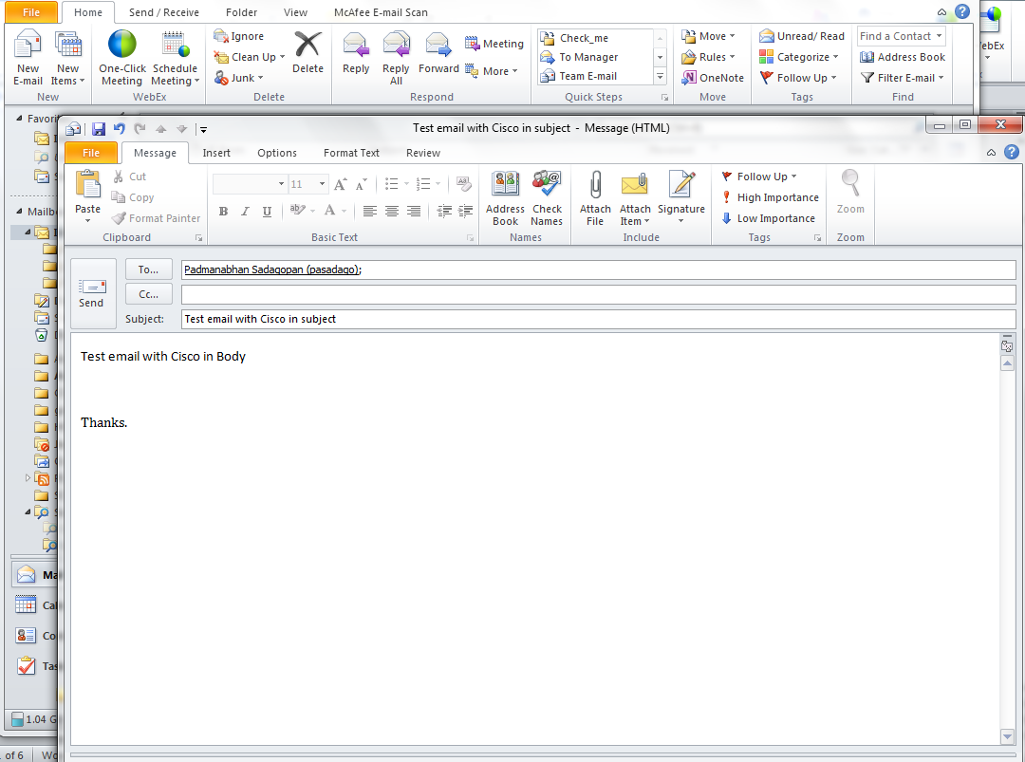

- Double click on the email you have just received. It will open a message window with ‘Cisco Support Community Related Discussions’ in bottom panel.

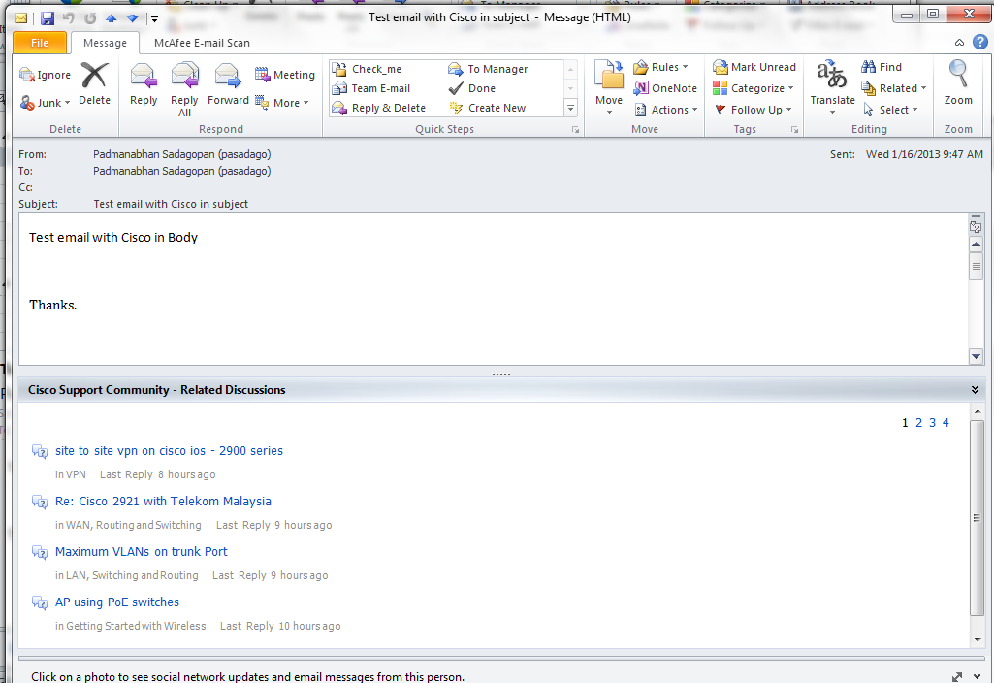

- Click on any of the page numbers (1 thru 4) to show discussions from that page. Discussions from Page 4 have shown here.

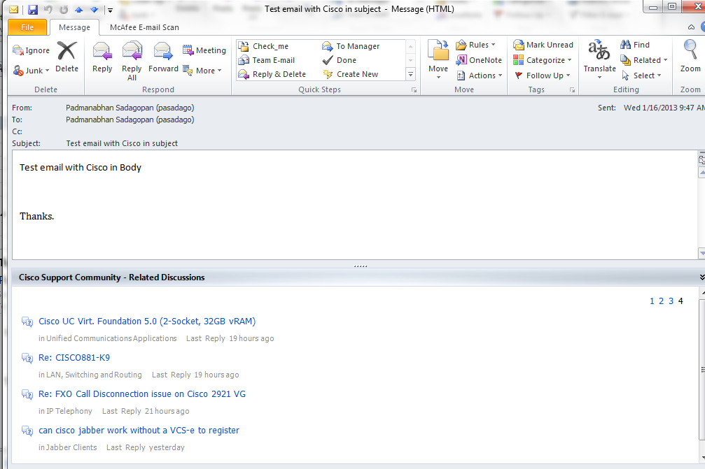

- Now left click and hold the curson on ‘Cisco support community – Related discussion’ title bar. It should bring a ‘control bar’. Click on control bar where to display the discussions window (top, bottom, right or left of the message)

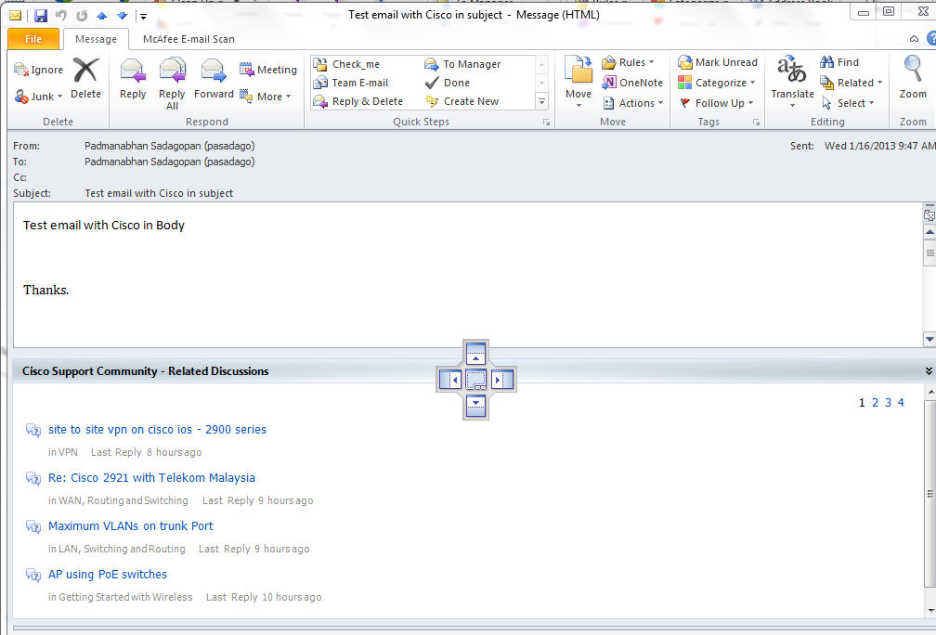

- With the control bar opened, click on the right side. Now the CSC discussion window appears to the right.

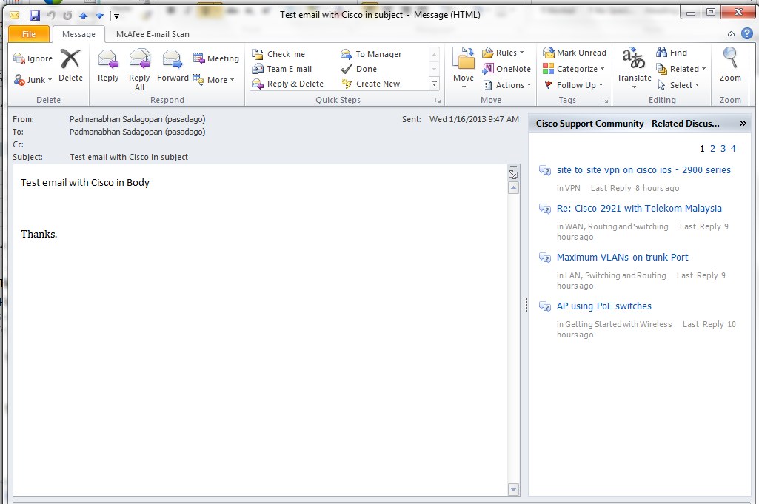

- Double click any of the hyperlinks for the CSC discussions. The discussion will be opened in a new browser. Check the discussion and close the browser.

- Now compose another email with subject and body has none of the keywords mentioned above. Then click ‘Send’.

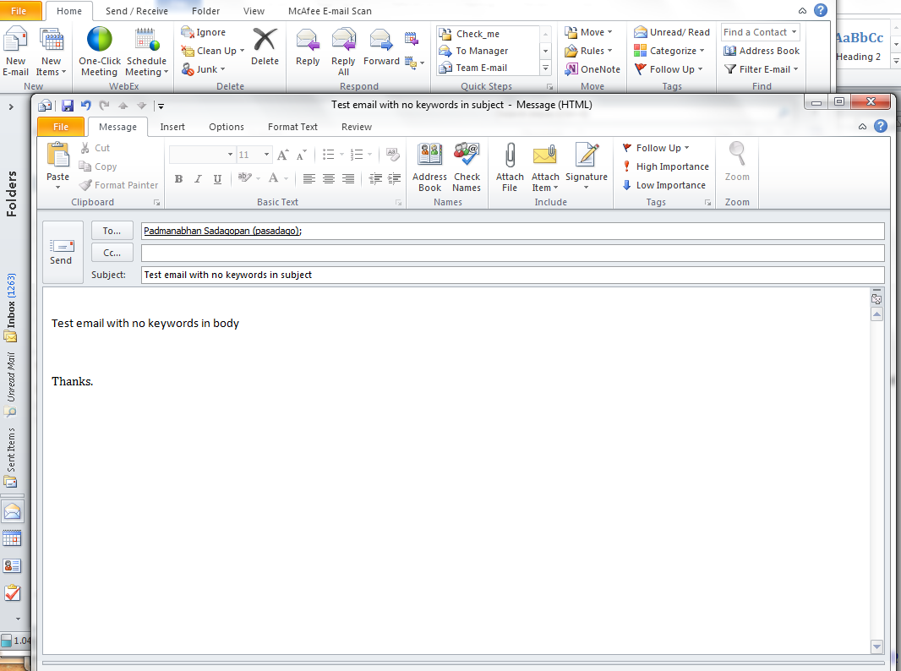

- Double click on the email you have just received. It will not show ‘Cisco Support Community Related Discussions’ in bottom panel.

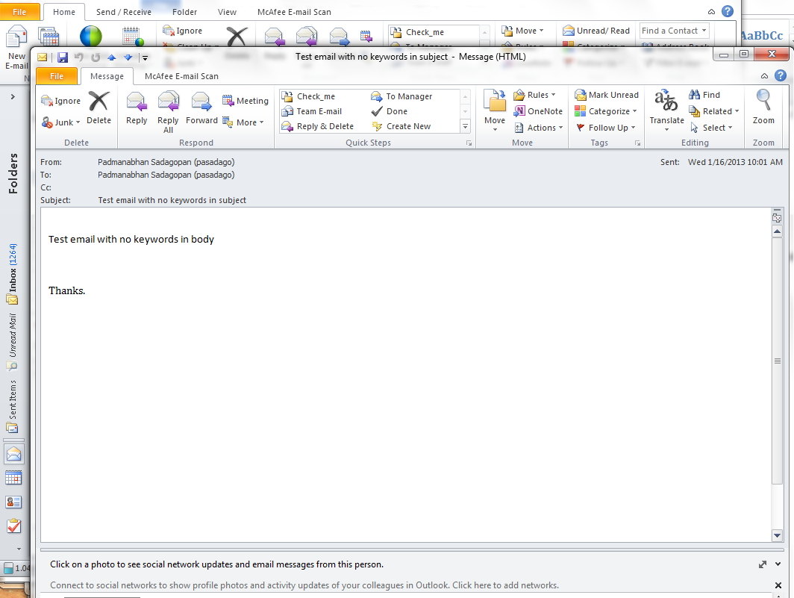

For further questions, email us at cscsocial@cisco.com
Please visit us at http://supportforums.cisco.com .

