Addendum to Detailed Design Document
Project:
Scoop: UCCX (HA) XML interaction with RESTful Web Service
Issue: Create URL Document - Post Feature unable to interact with Web Service adequately
Date: 10/8/11

Concept Testing In Lab
In lab, a similar RESTful web service was created using myeclipseide as below.
http://192.168.1.30:8080/restdemo/services/customers

Customer.java | CustomersResource.java
package com.myeclipseide.ws;  import javax.xml.bind.annotation.XmlRootElement;  @XmlRootElement  public class Customer {  private int id;  private String name;  private String address;  public int getId(){  return id;  }  public void setId(int id) {  this.id = id;  }  public String getName() {  return name;  }  public void setName(String name) {  this.name = name;  }  public String getAdress(){  return address;  }  public void setAddress(String address) {  this.address = address;  }  } | package com.myeclipseide.ws;  import java.util.ArrayList;  import java.util.List;  import java.util.TreeMap;  import javax.ws.rs.Consumes;  import javax.ws.rs.GET;  import javax.ws.rs.POST;  import javax.ws.rs.Path;  import javax.ws.rs.PathParam;  import javax.ws.rs.Produces;  import com.sun.jersey.spi.resource.Singleton;  @Produces("application/xml")  @Path("customers")  @Singleton  public class CustomersResource {  private TreeMap<Integer, Customer> customerMap = new TreeMap<Integer, Customer>();  public CustomersResource() {  // hard code one customer to demo  Customer customer = new Customer();  customer.setName("Harold Abernathy");  customer.setAddress("Sheffield, UK");  addCustomer(customer);  }  @GET  public List<Customer> getCustomers() {  List<Customer> customers = new ArrayList<Customer>();  customers.addAll(customerMap.values());  return customers;  }  @GET  @Path("{id}")  public Customer getCustomer(@PathParam("id") int cId) {  return customerMap.get(cId);  }  @POST  @Path("add")  @Produces("text/html")  @Consumes("application/xml")  public String addCustomer(Customer customer) {  int id = customerMap.size();  customer.setId(id);  customerMap.put(id, customer);  return "Customer " + customer.getName() + " added with Id " +id;  }  }

We can browse to the lab WebService to see the hardcoded PUT. See below.
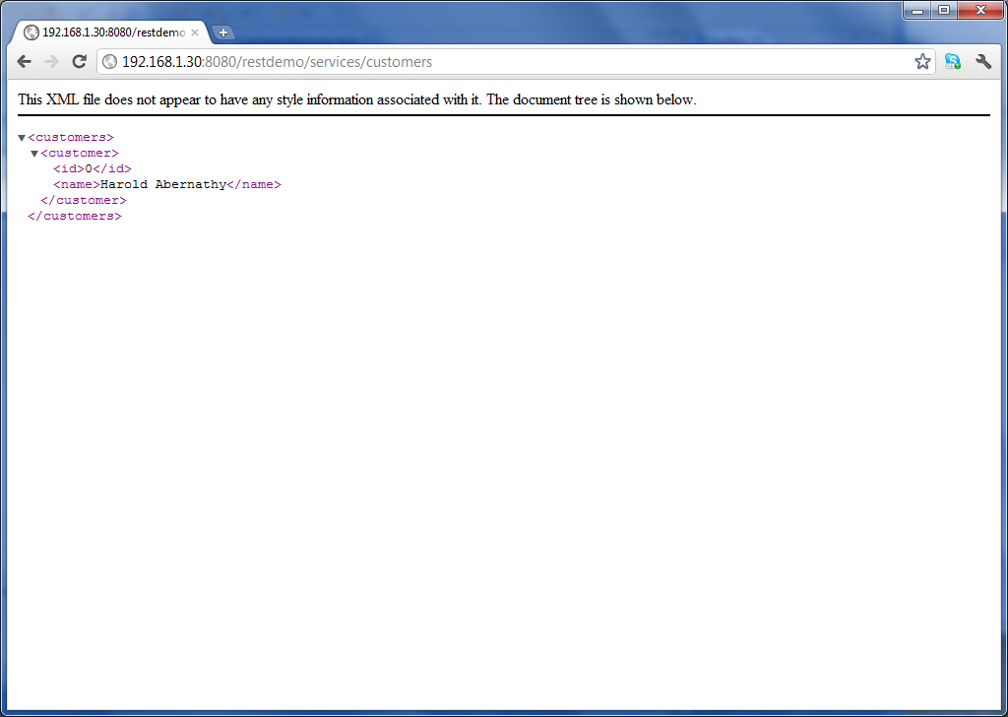

We can also POST another entry using the Firefox POSTER tool. Getting the following document returned.
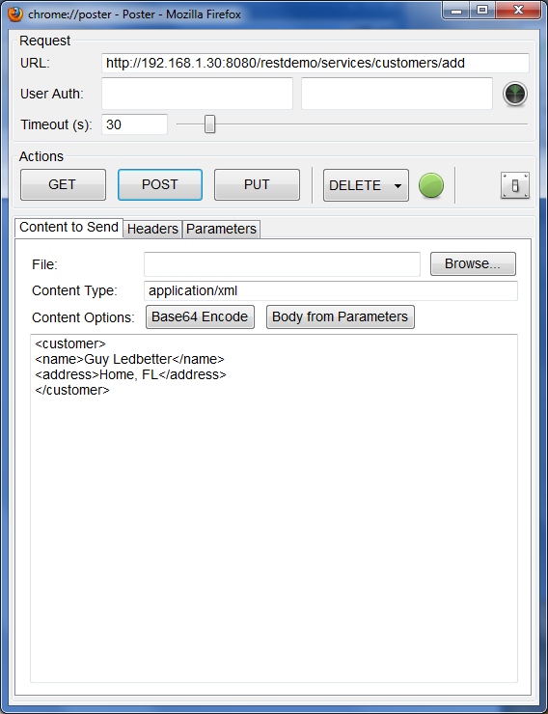 | 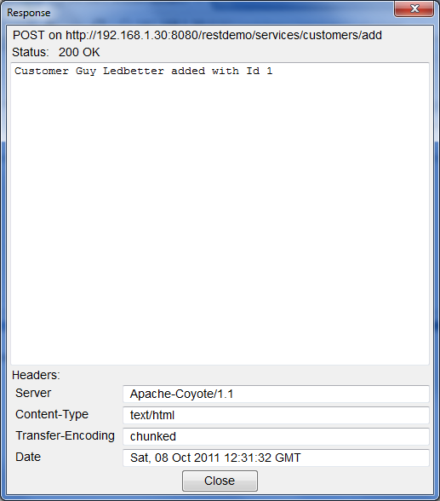

Again we can confirm the Add was completed.

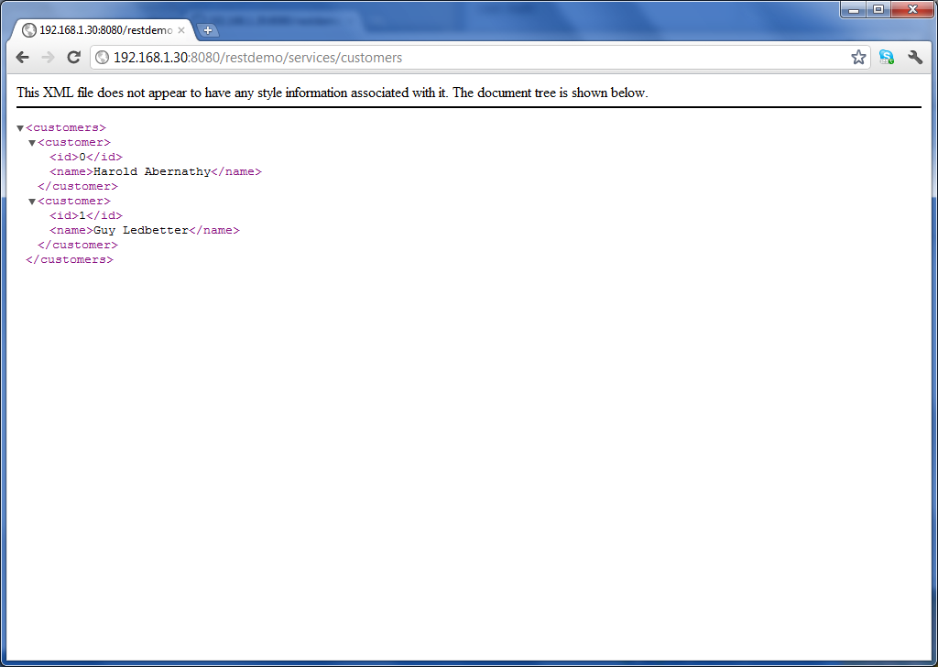

Similar to the POSTER tool, UCCX has the step, Create URL Document. However we are limited in that there is no free form content entry point, as in the POSTER tool. Instead we are limited to parameters.
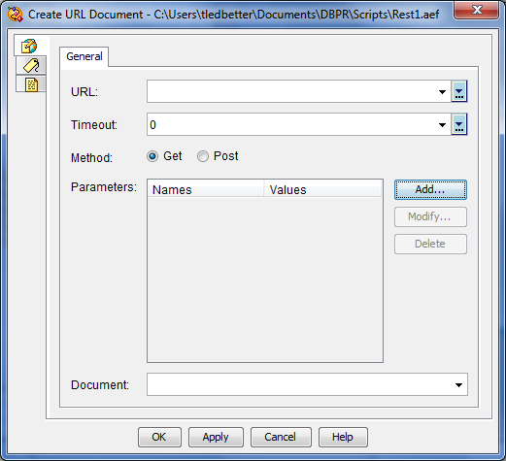

We could also use the Get HTTP Contact Info step in UCCX. However here we are limited to a query string.
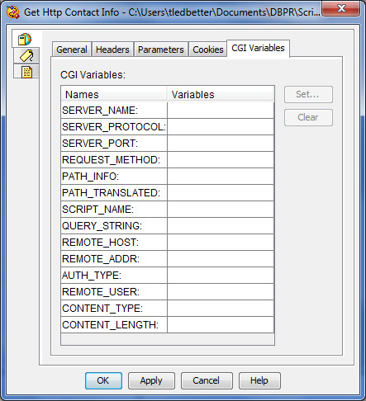

Attempts to use the POST method with parameters are rejected by the lab RESTful engine.
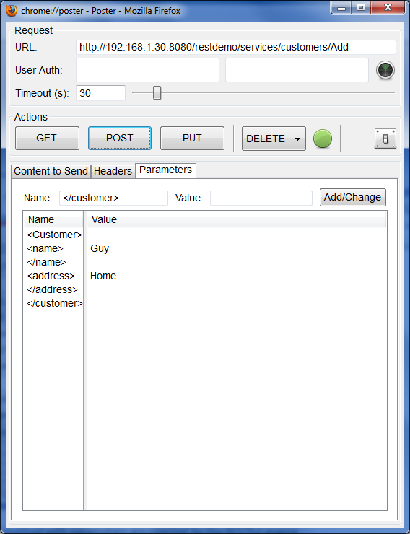 | 