Title to the document (Use this as Filename also)
Product(s)
sr#610447849_SRW_LAG_Trunk.doc
Question
How do I set up LAG trunks?
Keywords
LAG, Trunk, VLAN, SRW2016
Answer

These are instructions on configuring a LAG trunk between to SRW series switches, specifically SRW2016 in this case. Customer (sr# 601447849) has SRW2024’s and the SRW2016’s are suitable for testing this configuration. Only two VLANs will be tested in this configuration, VLAN 1 native, and VLAN 4000 (heartbeat and VMotion for VMWare server farm). Customer is using ports 22 and 23 in thair configuration, so will will use ports 15 and 16.

We begin by restoring factory defaults on the switches. Next we upgrade our switches to firware version 1.2.2. We then configure one SRW for IP address 192.168.1.250/24.

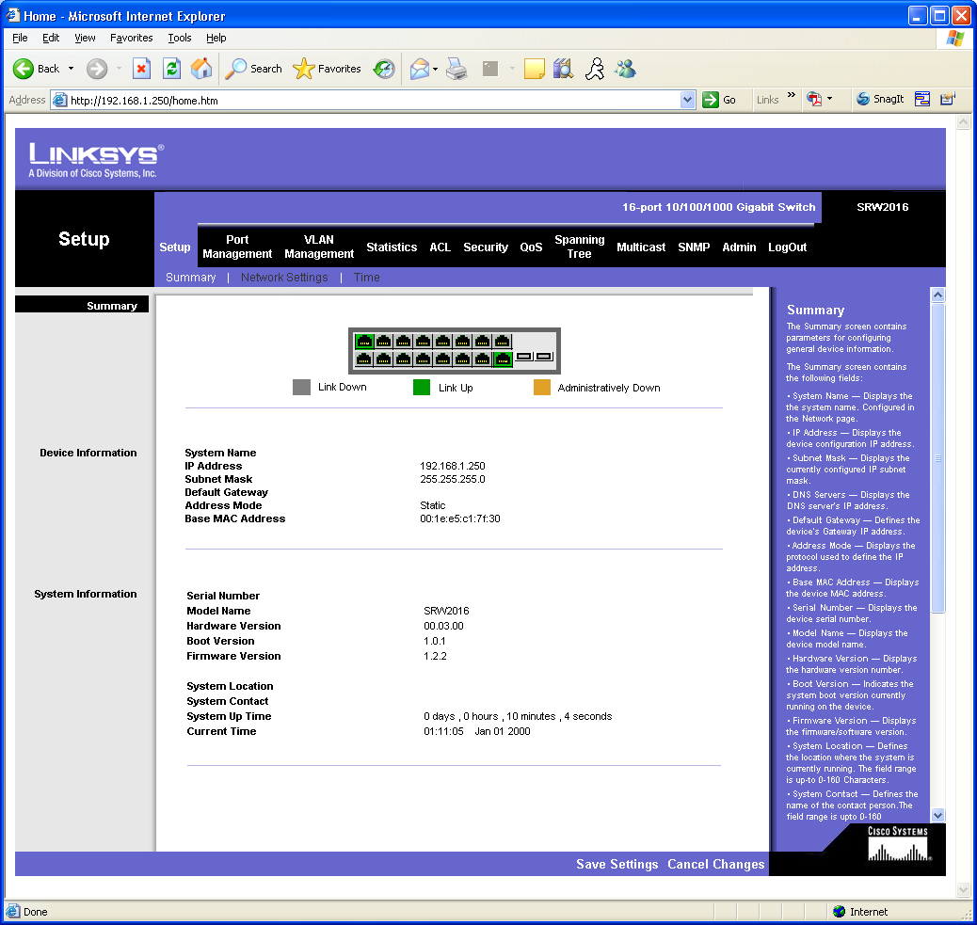

We add the additional VLAN, 4000, on the ‘VLAN Management’ tab. Type in 4000 in the ‘VLAN ID 92-4094):’ field. Click the ‘Add’ button to the right and then click ‘Save Settings’ at the bottom of the page.

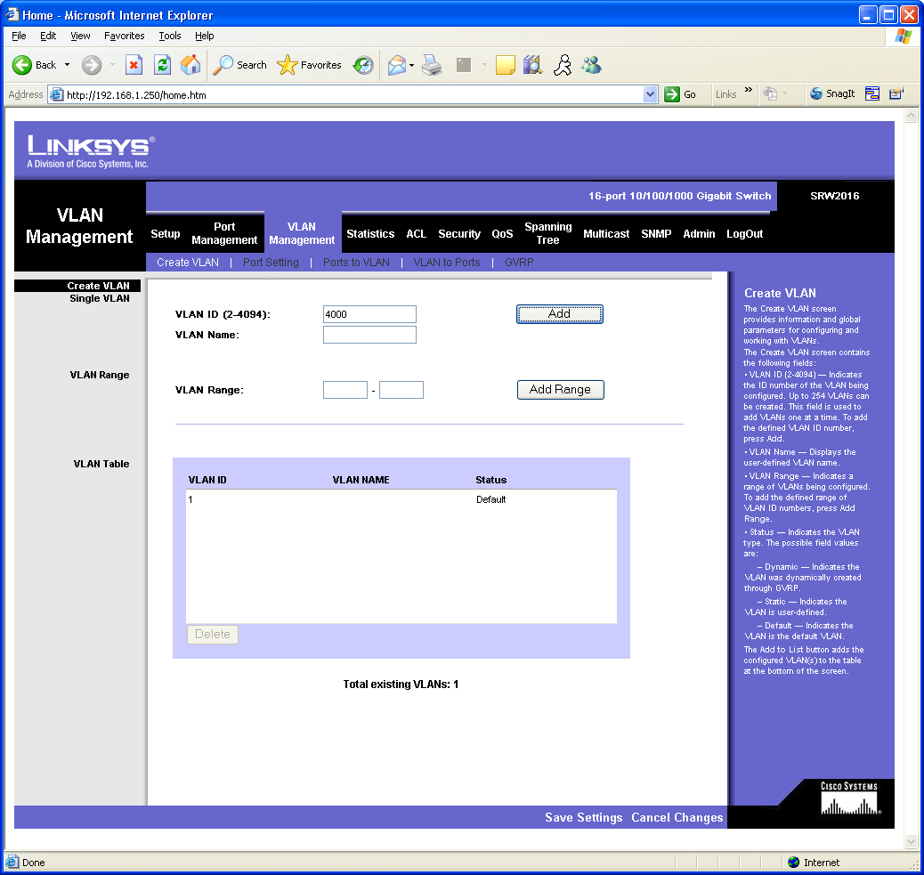

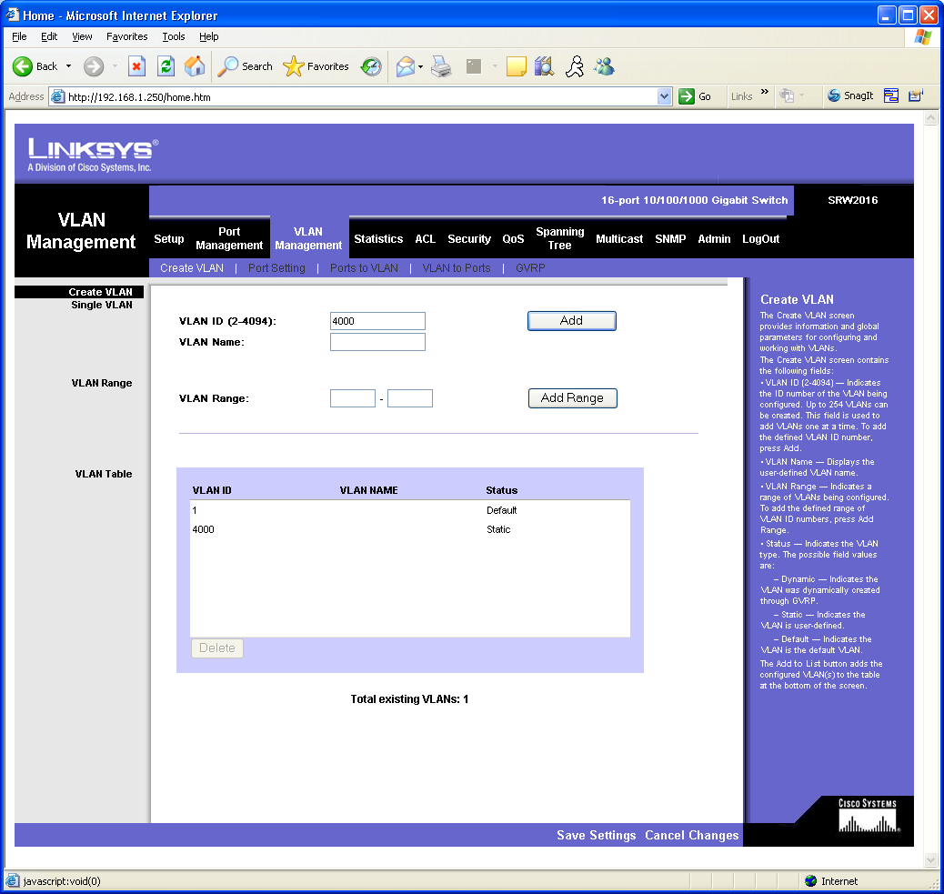

Next we go to the ‘Port Management ➔Link Aggregation’ tab to set up the LAG itself. We begin by clicking the detail button of LAG 1.

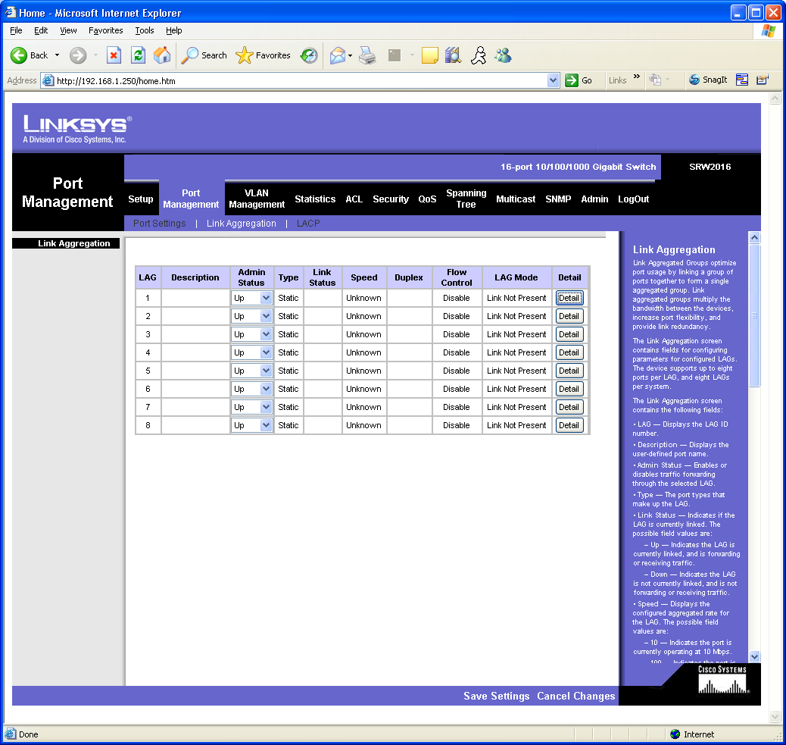

Click ports 15 and 16 at the bottom of the page under ‘Select Ports’. And click ‘Save & Close’.

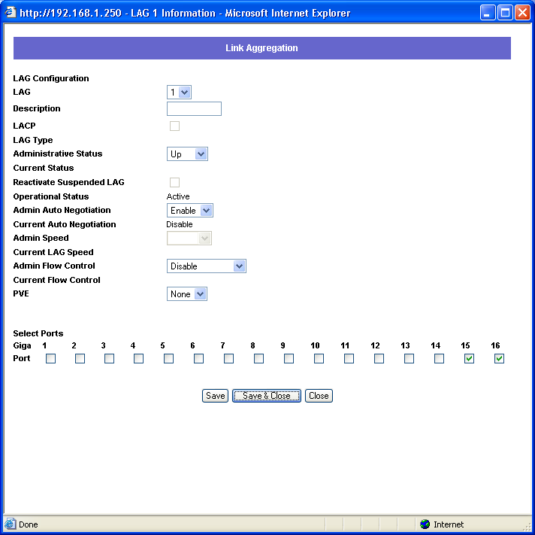

We now have a LAG configured for ports 15 and 16 as shown below. Note that it displays as down because the other switch is not plugged in.

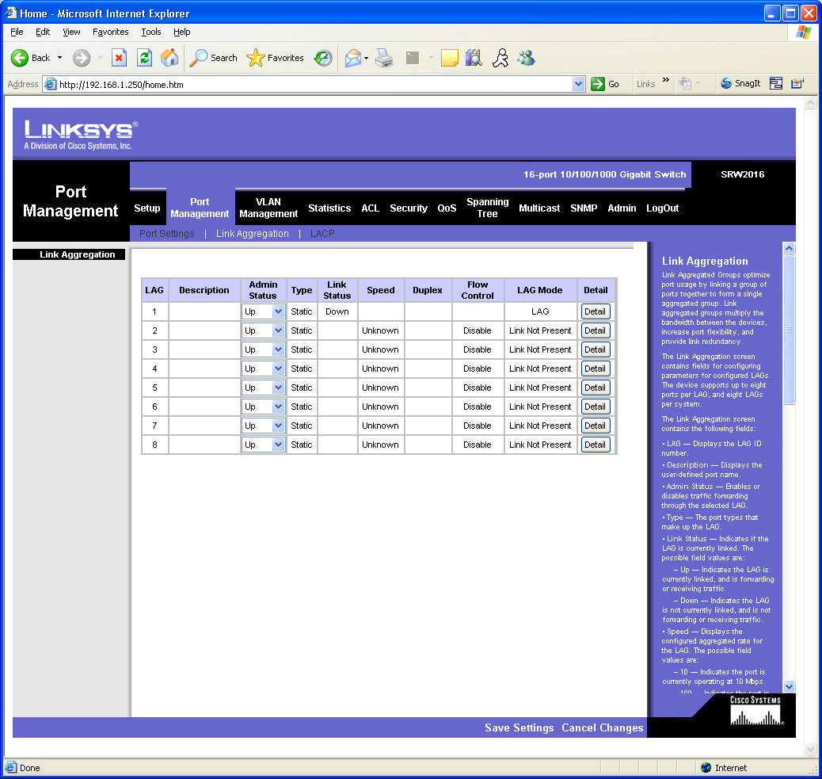

Here we see the SRW on the other side plugged in, with nothing but a factory configuration, the link is already showing ‘Up’ and a workstation on one switch may already ping another workstation on the other switch and vice versa.

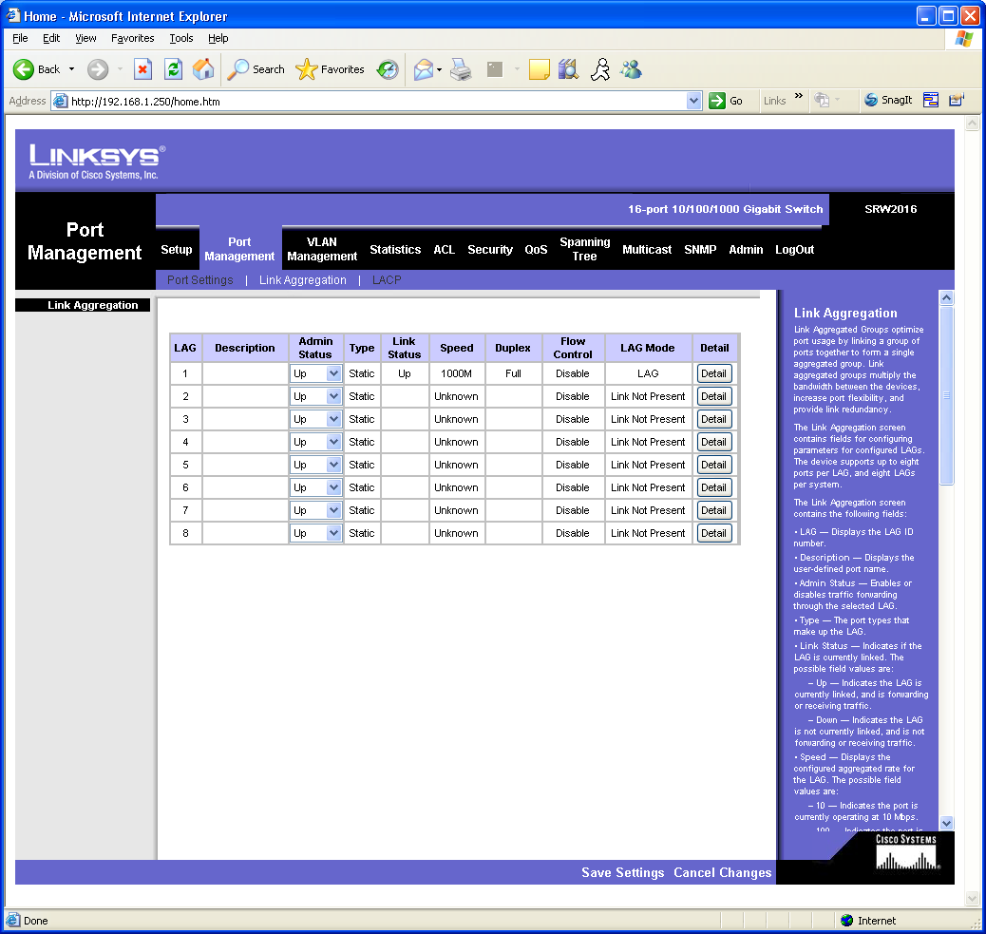

Now we will add Trunking to the LAG. Select the ‘VLAN Management ➔ Port Settings’ tab. On the ‘Mode’ dropdown to the right of LAG1, select ‘Trunk’ and click ‘Save Settings. Note that pings still work between the switches (even though the second has yet to be configured) as VLAN 1 is untagged.

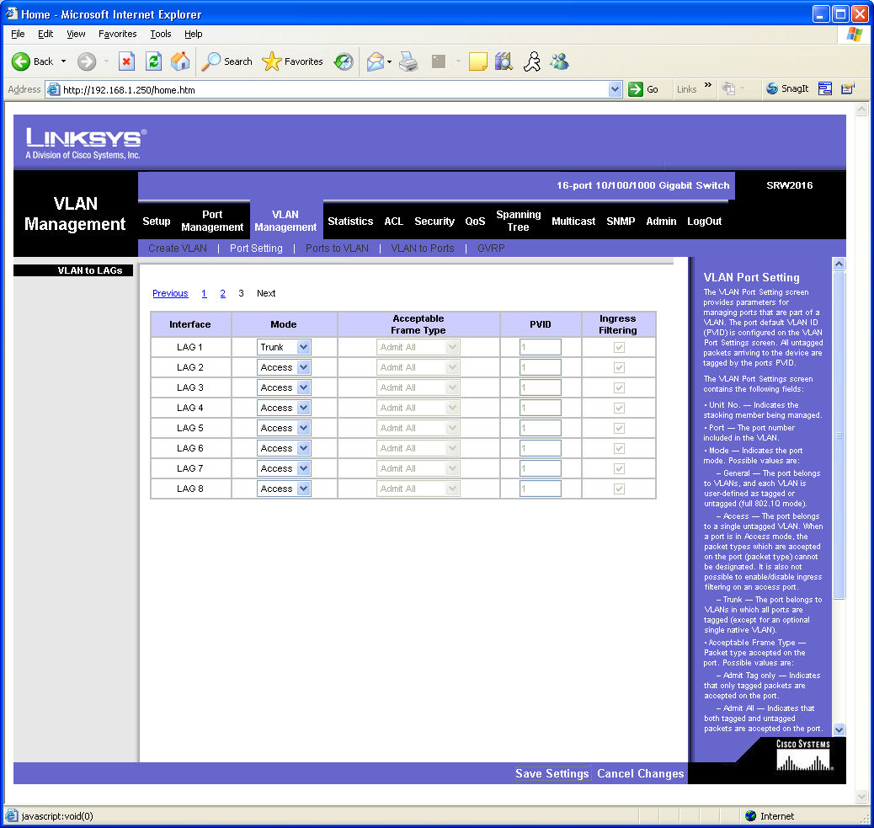

Select ‘VLAN Management ➔ Ports to VLAN’. Select VLAN 4000 from the ‘Select VLAN’ pull down. Once this is done, click the untagged option on port four. This assigns this port as an access port for DTE equipment. Also select the radio button ‘Tagged’ for LAG 1. This assigns VLAN 4000 to the Trunk so that it will pass its traffic. Click ‘Save Settings’.

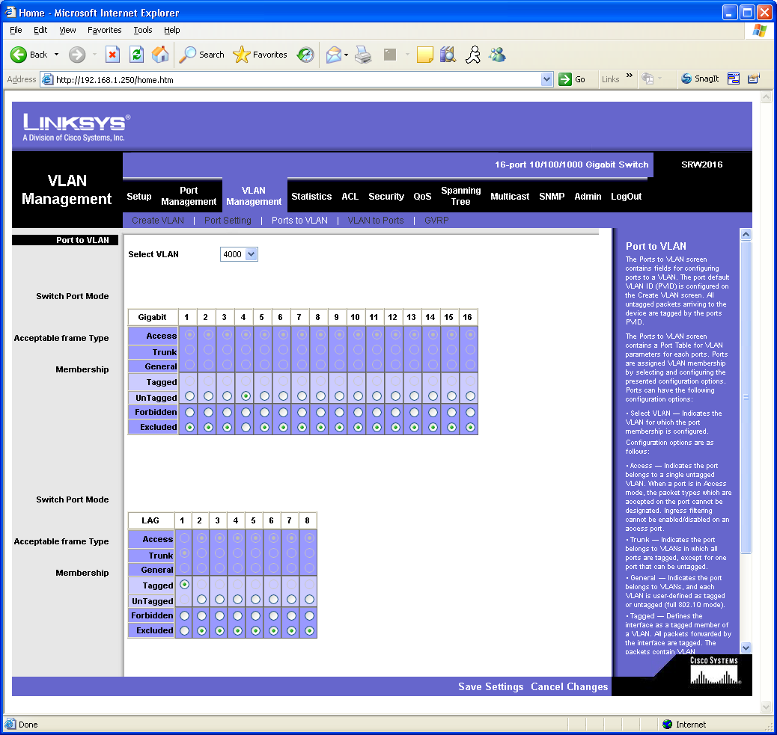

Verify the access port quickly from ‘VLAN Management’. You see port 4 has a PVID of 4000.

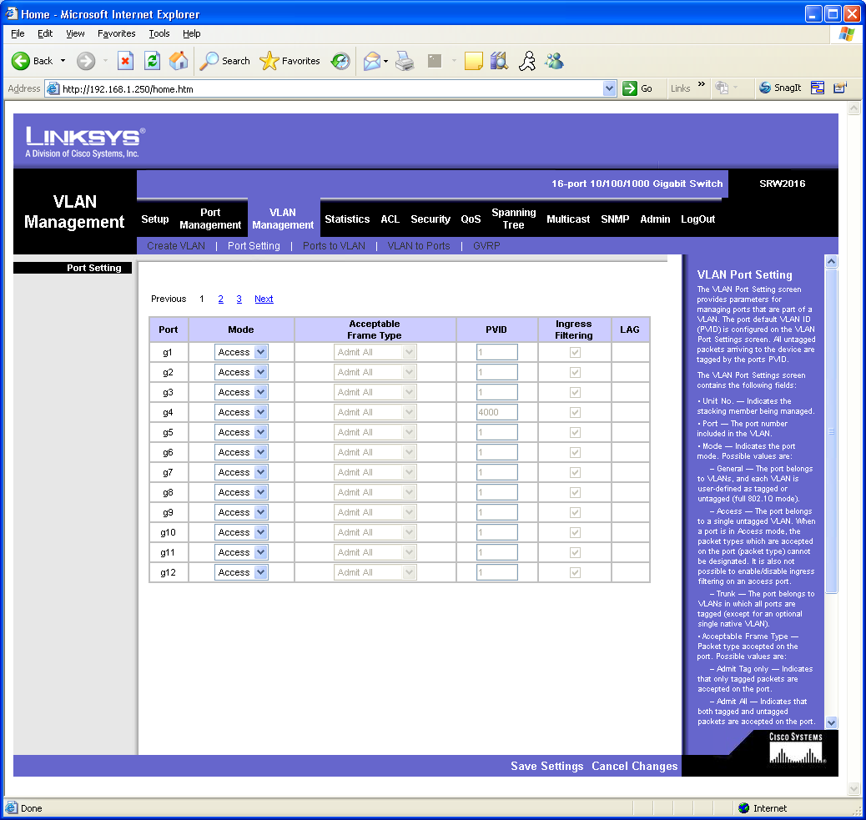

I prefer to verify Trunks from ‘VLAN Management ➔ VLAN to Ports’ tab by clicking ‘Join to VLAN’ buttons for the appropriate Trunk.

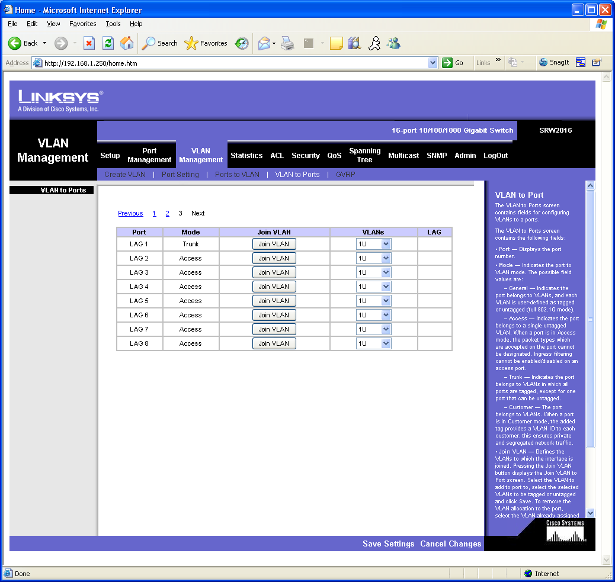

Our Trunk is well with VLAN 1 natively ‘U’ntagged and VLAN 4000 ‘T’agged.

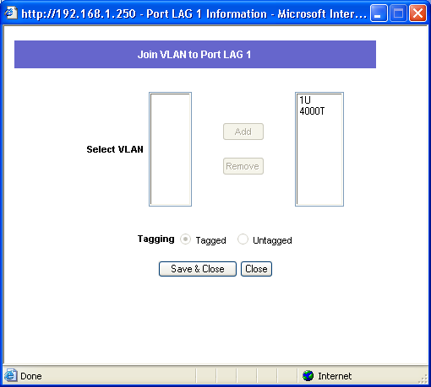

Repeat this procedure as appropriate on the secondary switch. Verify traffic passes over VLAN 4000 by plugging a workstation (or other device) into port 4 on each switch and pinging. In my case, I used two notebook computers with IP addresses of 192.168.1.41/24 and 192.168.1.14/24.

Example:
Prepared by Christopher Cooper
© 2006 Cisco Systems, Inc. All rights reserved.

