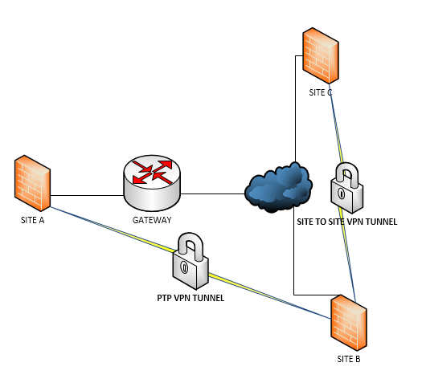

NEED TO GET TRAFFIC FROM SITE A TO SITE C