3650-24 port PoE switch.
The default power output is 390W.
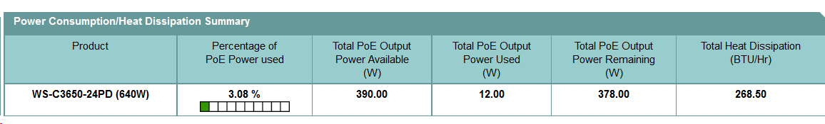
With the additional secondary power supply, it says that the total power available for PoE is 780W.
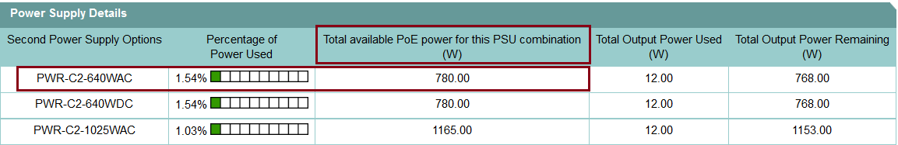

The link below says that it runs on redundant power supply on the section called, ‘Specification at a Glance’.
http://www.cisco.com/c/en/us/products/switches/catalyst-3650-series-switches/index.html

