Migrating Service Console to VEM

- Currently the initial install of ESX 3.5Ux or ESX 4.0 will result in the Service Console behind the vSwitch, and since you may want to change that....
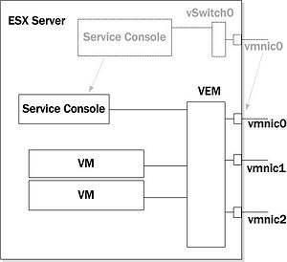
- Ensure the vlan associated with the Service Console's port group is already being sent to the VEM from the physical switch before attempting migration.

Contents
[hide]
- 1 Migrating the Service Console Virtual NIC from vSwitch to VEM
  - 1.1 Step-by-Step
  - 1.2 VI Client Before/After
  - 1.3 VSM Before/After (no change here)
  - 1.4 ESX Host Vemcmd Before/After
  - 1.5 ESX Host esxcfg Before/After
- 2 Migrating vmnic0 from vSwitch to VEM
  - 2.1 Step-by-step
  - 2.2 VI Client Before/After
  - 2.3 VSM Before/After (no change here)
  - 2.4 ESX Host Vemcmd Before/After
  - 2.5 ESX Host esxcfg Before/After
- 3 Post Migration
- 4 Additional Guides

Migrating the Service Console Virtual NIC from vSwitch to VEM

Step-by-Step
- Create a port-profile on the VSM that has the Service Console's vlan in it.
port-profile servicecon
vmware port-group
switchport mode access
switchport access vlan 104<---
no shutdown
system vlan 104
state enabled
- Make sure there is an uplink port-profile that already has the service console vlan.
port-profile sysuplink1
capability uplink
vmware port-group
switchport mode trunk
switchport trunk allowed vlan 104,110,120,130<---
no shutdown
system vlan 110,120,130
state enabled
- Migrate the Service Console by going to Host's Configuration Tab and follow the steps below
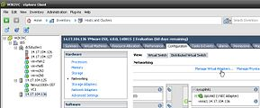  Manage Virtual Adapters | 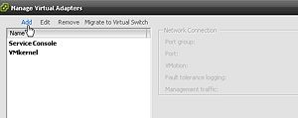  Add | 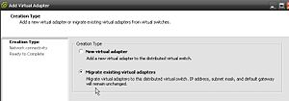  Migrate Existing Virtual Adapters
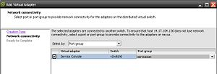  Pick the port-profile for Service Console | 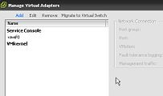  Looking Good

VI Client Before/After
Before | After
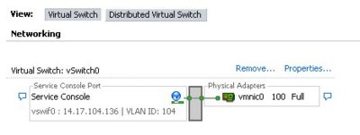 | 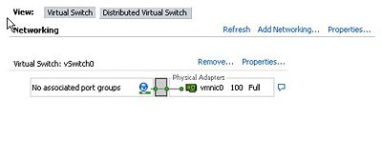
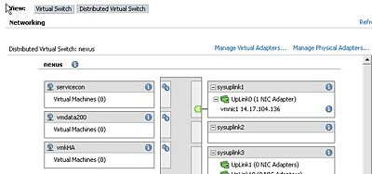 | 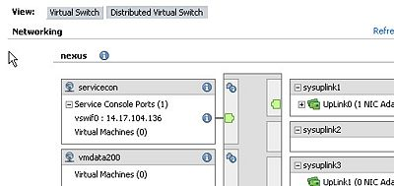

VSM Before/After (no change here)
Before | After
port-profile sysuplink1  capability uplink  vmware port-group  switchport mode trunk  switchport trunk allowed vlan 104,110,120,130  no shutdown  system vlan 110,120,130  state enabled  port-profile servicecon  vmware port-group  switchport mode access  switchport access vlan 104  no shutdown  system vlan 104  state enabled | port-profile sysuplink1  capability uplink  vmware port-group  switchport mode trunk  switchport trunk allowed vlan 104,110,120,130  no shutdown  system vlan 110,120,130  state enabled  port-profile servicecon  vmware port-group  switchport mode access  switchport access vlan 104  no shutdown  system vlan 104  state enabled

ESX Host Vemcmd Before/After
Before | After
[root@server51 /]# vemcmd show port  LTL IfIndex Vlan Bndl SG_ID Pinned_SGID Type Admin State CBL Mode Name  1 15f00010 3968 0 2 2 VIRT UP UP 4 Access inband  2 7000000 1 0 2 2 VIRT UP UP 0 Access aipc  3 15f00020 1 0 2 2 VIRT UP UP 4 Access span  5 15f00040 3968 0 2 2 VIRT UP UP 4 Access inband port security  8 0 3969 0 2 2 VIRT UP UP 4 Access l20  9 0 3969 0 2 2 VIRT UP UP 4 Access l21  10 0 110 0 2 2 VIRT UP UP 4 Access l22  11 0 3968 0 2 2 VIRT UP UP 4 Access l23  12 0 120 0 2 2 VIRT UP UP 4 Access l24  13 0 1 0 2 2 VIRT UP UP 0 Access l25  14 0 1 0 2 2 VIRT UP UP 0 Access l26  16 1a040100 1 T 0 2 2 PHYS UP UP 1 Trunk vmnic1 | [root@server51 /]# vemcmd show port  LTL IfIndex Vlan Bndl SG_ID Pinned_SGID Type Admin State CBL Mode Name  1 15f00010 3968 0 2 2 VIRT UP UP 4 Access inband  2 7000000 1 0 2 2 VIRT UP UP 0 Access aipc  3 15f00020 1 0 2 2 VIRT UP UP 4 Access span  5 15f00040 3968 0 2 2 VIRT UP UP 4 Access inband port security  8 0 3969 0 2 2 VIRT UP UP 4 Access l20  9 0 3969 0 2 2 VIRT UP UP 4 Access l21  10 0 110 0 2 2 VIRT UP UP 4 Access l22  11 0 3968 0 2 2 VIRT UP UP 4 Access l23  12 0 120 0 2 2 VIRT UP UP 4 Access l24  13 0 1 0 2 2 VIRT UP UP 0 Access l25  14 0 1 0 2 2 VIRT UP UP 0 Access l26  16 1a040100 1 T 0 2 2 PHYS UP UP 1 Trunk vmnic1  47 1b040000 104 0 2 2 VIRT UP UP 4 Access vswif0
[root@server51 /]# vemcmd show trunk  Trunk port 16 native_vlan 1 CBL 1  vlan(1) cbl 1, vlan(104) cbl 4, vlan(110) cbl 4, vlan(120) cbl 4, vlan(130) cbl 4, | [root@server51 /]# vemcmd show trunk  Trunk port 16 native_vlan 1 CBL 1  vlan(1) cbl 1, vlan(104) cbl 4, vlan(110) cbl 4, vlan(120) cbl 4, vlan(130) cbl 4,
[root@server51 /]# vss status  VSS modules are loaded  Switch Name Num Ports Used Ports Configured Ports MTU Uplinks  vSwitch0 32 3 32 1500 vmnic0  DVS Name Num Ports Used Ports Configured Ports Uplinks  nexus 256 8 256 vmnic1  DPA is running | [root@server51 /]# vss status  VSS modules are loaded  Switch Name Num Ports Used Ports Configured Ports MTU Uplinks  vSwitch0 32 2 32 1500 vmnic0  DVS Name Num Ports Used Ports Configured Ports Uplinks  nexus 256 9 256 vmnic1  DPA is running
[root@server51 /]# vemcmd show bd 110  BD 110, vdc 1, vlan 110, 2 ports  Portlist:  10 l22  16 vmnic1  [root@server51 /]# vemcmd show bd 120  BD 120, vdc 1, vlan 120, 2 ports  Portlist:  12 l24  16 vmnic1  [root@server51 /]# vemcmd show bd 104  BD 104, vdc 1, vlan 104, 2 ports  Portlist:  16 vmnic1  Multicast Group Table:  Group 0.0.0.0 RID 5 Multicast LTL 4409  16 | [root@server51 /]# vemcmd show bd 110  BD 110, vdc 1, vlan 110, 2 ports  Portlist:  10 l22  16 vmnic1  [root@server51 /]# vemcmd show bd 10  [root@server51 /]# vemcmd show bd 120  BD 120, vdc 1, vlan 120, 2 ports  Portlist:  12 l24  16 vmnic1  [root@server51 /]# vemcmd show bd 104  BD 104, vdc 1, vlan 104, 2 ports  Portlist:  16 vmnic1  47 vswif0  Multicast Group Table:  Group 0.0.0.0 RID 5 Multicast LTL 4409  16

ESX Host esxcfg Before/After
Before | After
[root@server51 /]# esxcfg-vswitch -l  Switch Name Num Ports Used Ports Configured Ports MTU Uplinks  vSwitch0 32 3 32 1500 vmnic0  PortGroup Name VLAN ID Used Ports Uplinks  Service Console 104 1 vmnic0  DVS Name Num Ports Used Ports Configured Ports Uplinks  nexus 256 8 256 vmnic1  DVPort ID In Use Client  160 1 vmnic1  161 0  162 0  163 0  164 0  165 0  166 0  167 0  168 0  169 0  170 0  171 0  172 0  173 0  174 0  175 0 | [root@server51 /]# esxcfg-vswitch -l  Switch Name Num Ports Used Ports Configured Ports MTU Uplinks  vSwitch0 32 2 32 1500 vmnic0  PortGroup Name VLAN ID Used Ports Uplinks  DVS Name Num Ports Used Ports Configured Ports Uplinks  nexus 256 9 256 vmnic1  DVPort ID In Use Client  160 1 vmnic1  161 0  162 0  163 0  164 0  165 0  166 0  167 0  168 0  169 0  170 0  171 0  172 0  173 0  174 0  175 0  66 1 vswif0
[root@server51 /]# esxcfg-vswif -l  Name Port Group/DVPort IP Family IP Address Netmask Broadcast Enabled TYPE  vswif0 Service Console IPv4 14.17.104.136 255.255.255.0 14.17.104.255 true STATIC | [root@server51 /]# esxcfg-vswif -l  Name Port Group/DVPort IP Family IP Address Netmask Broadcast Enabled TYPE  vswif0 66 IPv4 14.17.104.136 255.255.255.0 14.17.104.255 true STATIC

Migrating vmnic0 from vSwitch to VEM

Step-by-step
- Migrate vmnic0 by going to Host's Configuration Tab and follow the steps below
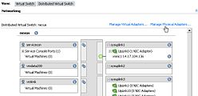  Manage Physical Adapters | 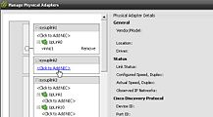  Click to Add NIC | 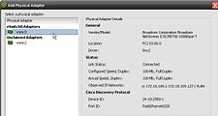  Select vmnic0
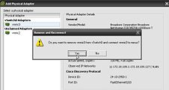  YES | 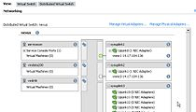  vmnic0 unders sysuplink2 | 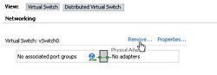  Vswitch can be removed
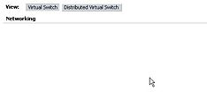
Vswitch is gone

VI Client Before/After
Before | After
 | 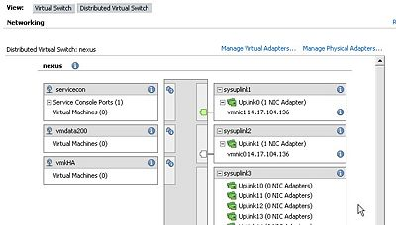

VSM Before/After (no change here)
Before | After
port-profile sysuplink2  capability uplink  vmware port-group  switchport mode trunk  switchport trunk allowed vlan 104  no shutdown  system vlan 104  state enabled  port-profile servicecon  vmware port-group  switchport mode access  switchport access vlan 104  no shutdown  system vlan 104  state enabled | port-profile sysuplink2  capability uplink  vmware port-group  switchport mode trunk  switchport trunk allowed vlan 104  no shutdown  system vlan 104  state enabled  port-profile servicecon  vmware port-group  switchport mode access  switchport access vlan 104  no shutdown  system vlan 104  state enabled

ESX Host Vemcmd Before/After
Before | After
[root@server51 /]# vemcmd show port  LTL IfIndex Vlan Bndl SG_ID Pinned_SGID Type Admin State CBL Mode Name  1 15f00010 3968 0 2 2 VIRT UP UP 4 Access inband  2 7000000 1 0 2 2 VIRT UP UP 0 Access aipc  3 15f00020 1 0 2 2 VIRT UP UP 4 Access span  5 15f00040 3968 0 2 2 VIRT UP UP 4 Access inband port security  8 0 3969 0 2 2 VIRT UP UP 4 Access l20  9 0 3969 0 2 2 VIRT UP UP 4 Access l21  10 0 110 0 2 2 VIRT UP UP 4 Access l22  11 0 3968 0 2 2 VIRT UP UP 4 Access l23  12 0 120 0 2 2 VIRT UP UP 4 Access l24  13 0 1 0 2 2 VIRT UP UP 0 Access l25  14 0 1 0 2 2 VIRT UP UP 0 Access l26  16 1a040100 1 T 0 2 2 PHYS UP UP 1 Trunk vmnic1  47 1b040000 104 0 2 2 VIRT UP UP 4 Access vswif0 | [root@server51 /]# vemcmd show port  LTL IfIndex Vlan Bndl SG_ID Pinned_SGID Type Admin State CBL Mode Name  1 15f00010 3968 0 2 2 VIRT UP UP 4 Access inband  2 7000000 1 0 2 2 VIRT UP UP 0 Access aipc  3 15f00020 1 0 2 2 VIRT UP UP 4 Access span  5 15f00040 3968 0 2 2 VIRT UP UP 4 Access inband port security  8 0 3969 0 2 2 VIRT UP UP 4 Access l20  9 0 3969 0 2 2 VIRT UP UP 4 Access l21  10 0 110 0 2 2 VIRT UP UP 4 Access l22  11 0 3968 0 2 2 VIRT UP UP 4 Access l23  12 0 120 0 2 2 VIRT UP UP 4 Access l24  13 0 1 0 2 2 VIRT UP UP 0 Access l25  14 0 1 0 2 2 VIRT UP UP 0 Access l26  15 1a040000 1 T 0 2 2 PHYS UP UP 1 Trunk vmnic0  16 1a040100 1 T 0 2 2 PHYS UP UP 1 Trunk vmnic1  47 1b040000 104 0 2 2 VIRT UP UP 4 Access vswif0
[root@server51 /]# vemcmd show trunk  Trunk port 16 native_vlan 1 CBL 1  vlan(1) cbl 1, vlan(104) cbl 4, vlan(110) cbl 4, vlan(120) cbl 4, vlan(130) cbl 4, | [root@server51 /]# vemcmd show trunk  Trunk port 15 native_vlan 1 CBL 1  vlan(1) cbl 1, vlan(104) cbl 4,  Trunk port 16 native_vlan 1 CBL 1  vlan(1) cbl 1, vlan(104) cbl 4, vlan(110) cbl 4, vlan(120) cbl 4, vlan(130) cbl 4,
[root@server51 /]# vss status  VSS modules are loaded  Switch Name Num Ports Used Ports Configured Ports MTU Uplinks  vSwitch0 32 2 32 1500 vmnic0  DVS Name Num Ports Used Ports Configured Ports Uplinks  nexus 256 9 256 vmnic1  DPA is running | [root@server51 /]# vss status  VSS modules are loaded  DVS Name Num Ports Used Ports Configured Ports Uplinks  nexus 256 10 256 vmnic0,vmnic1  DPA is running
[root@server51 /]# vemcmd show bd 110  BD 110, vdc 1, vlan 110, 2 ports  Portlist:  10 l22  16 vmnic1  [root@server51 /]# vemcmd show bd 120  BD 120, vdc 1, vlan 120, 2 ports  Portlist:  12 l24  16 vmnic1  [root@server51 /]# vemcmd show bd 104  BD 104, vdc 1, vlan 104, 2 ports  Portlist:  16 vmnic1  47 vswif0  Multicast Group Table:  Group 0.0.0.0 RID 5 Multicast LTL 4409  16 | [root@server51 /]# vemcmd show bd 110  BD 110, vdc 1, vlan 110, 2 ports  Portlist:  10 l22  16 vmnic1  [root@server51 /]# vemcmd show bd 120  BD 120, vdc 1, vlan 120, 2 ports  Portlist:  12 l24  16 vmnic1  [root@server51 /]# vemcmd show bd 104  BD 104, vdc 1, vlan 104, 3 ports  Portlist:  15 vmnic0  16 vmnic1  47 vswif0

ESX Host esxcfg Before/After
Before | After
[root@server51 /]# esxcfg-vswitch -l  Switch Name Num Ports Used Ports Configured Ports MTU Uplinks  vSwitch0 32 2 32 1500 vmnic0  PortGroup Name VLAN ID Used Ports Uplinks  DVS Name Num Ports Used Ports Configured Ports Uplinks  nexus 256 9 256 vmnic1  DVPort ID In Use Client  160 1 vmnic1  161 0  162 0  163 0  164 0  165 0  166 0  167 0  168 0  169 0  170 0  171 0  172 0  173 0  174 0  175 0  66 1 vswif0 | [root@server51 /]# esxcfg-vswitch -l  DVS Name Num Ports Used Ports Configured Ports Uplinks  nexus 256 10 256 vmnic0,vmnic1  DVPort ID In Use Client  160 1 vmnic1  161 1 vmnic0  162 0  163 0  164 0  165 0  166 0  167 0  168 0  169 0  170 0  171 0  172 0  173 0  174 0  175 0  66 1 vswif0
[root@server51 /]# esxcfg-vswif -l  Name Port Group/DVPort IP Family IP Address Netmask Broadcast Enabled TYPE  vswif0 66 IPv4 14.17.104.136 255.255.255.0 14.17.104.255 true STATIC | [root@server51 /]# esxcfg-vswif -l  Name Port Group/DVPort IP Family IP Address Netmask Broadcast Enabled TYPE  vswif0 66 IPv4 14.17.104.136 255.255.255.0 14.17.104.255 true STATIC

Post Migration
- See System Vlan Guidelines to ensure manageability.

