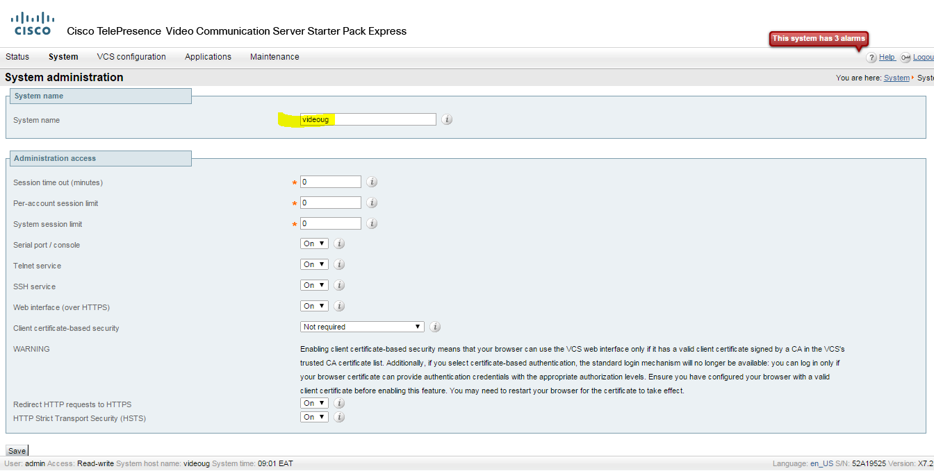

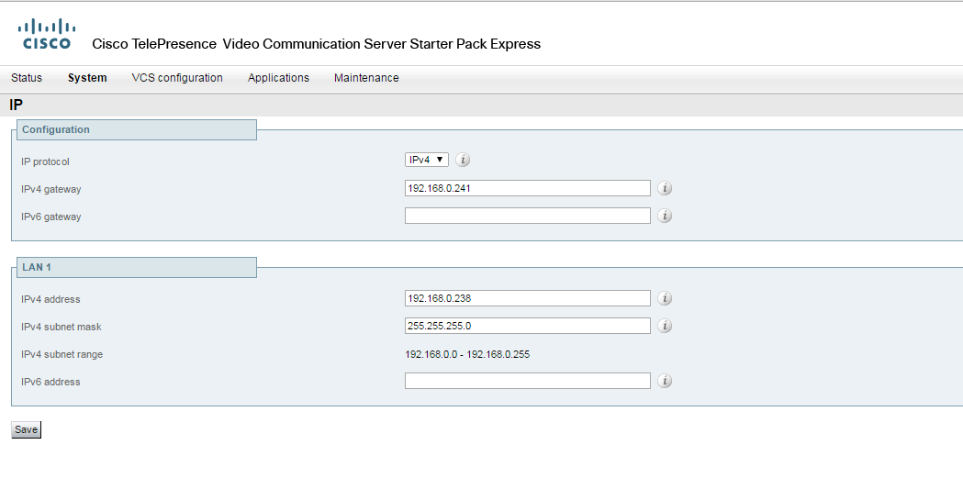
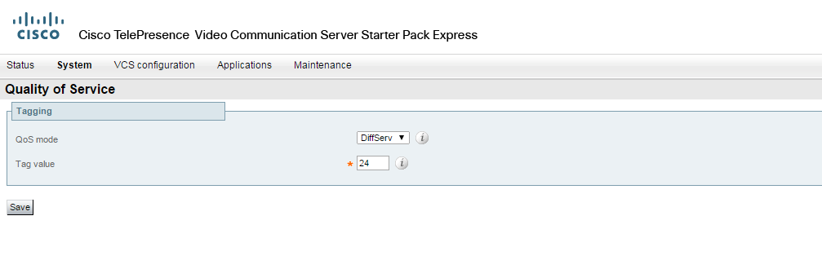
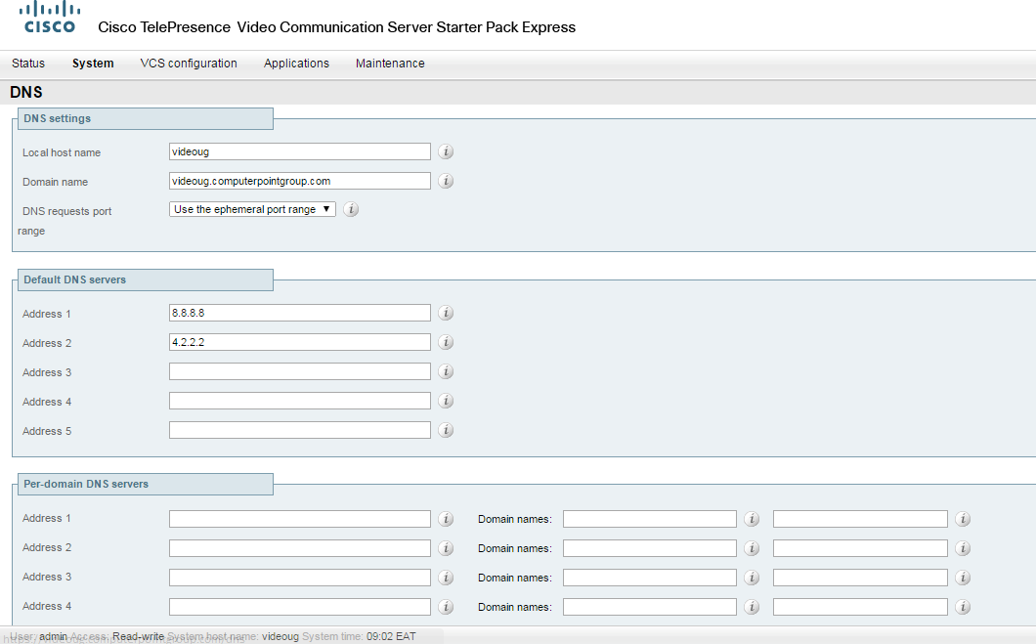

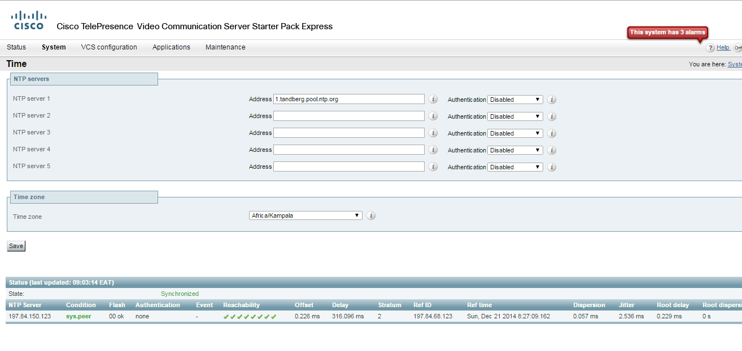
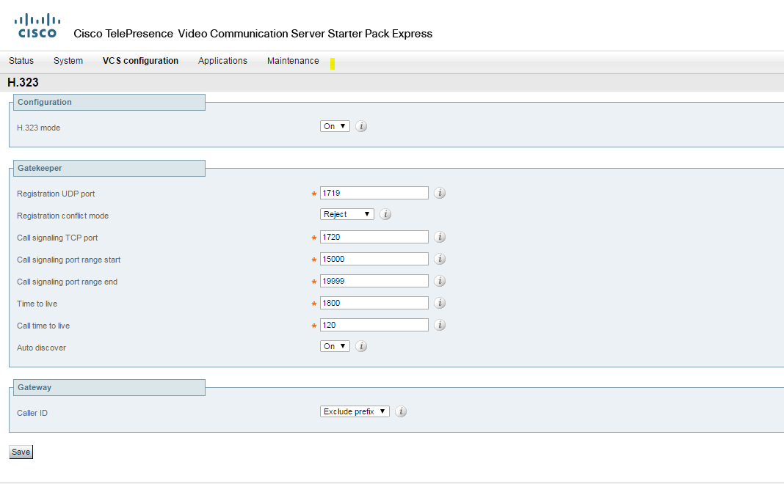
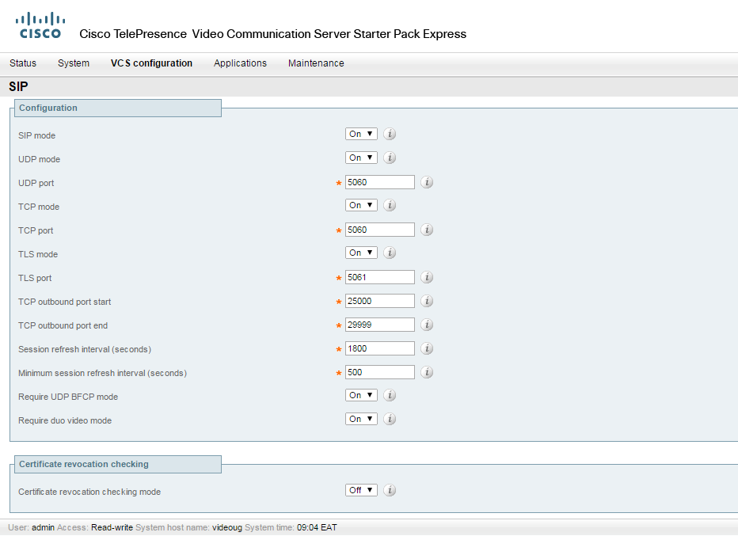
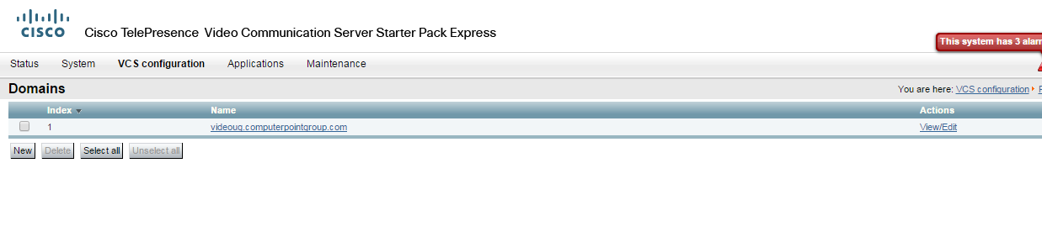
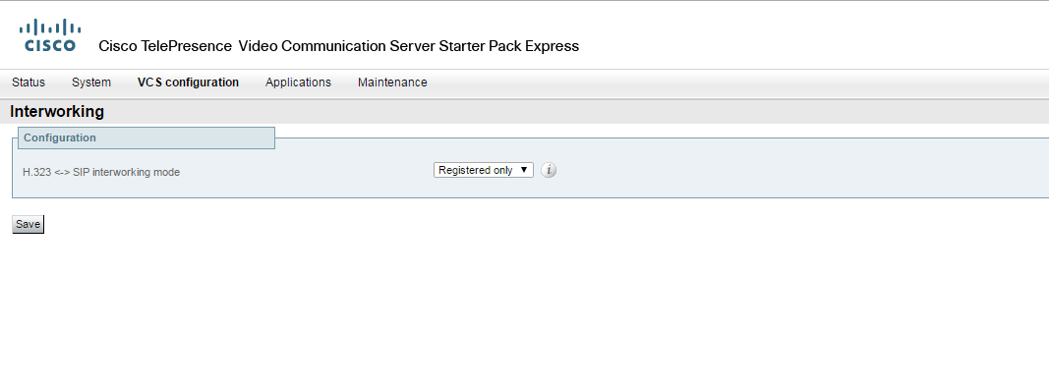
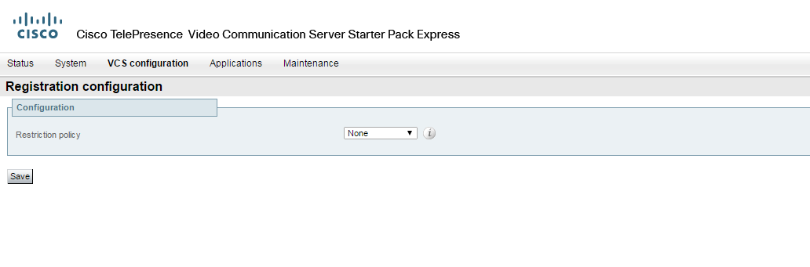
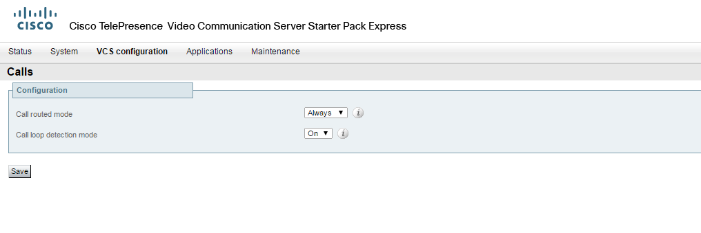
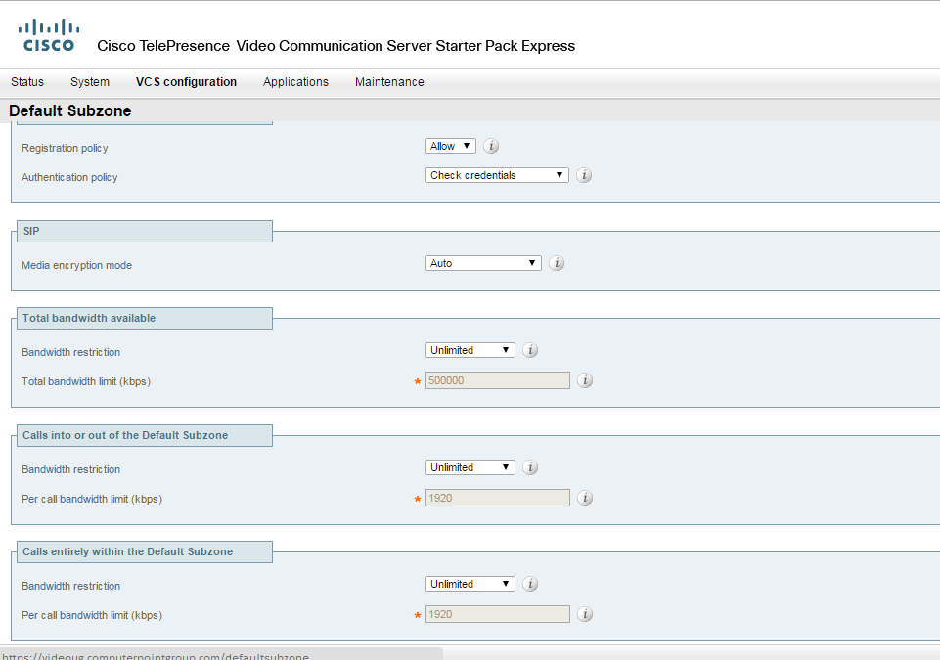
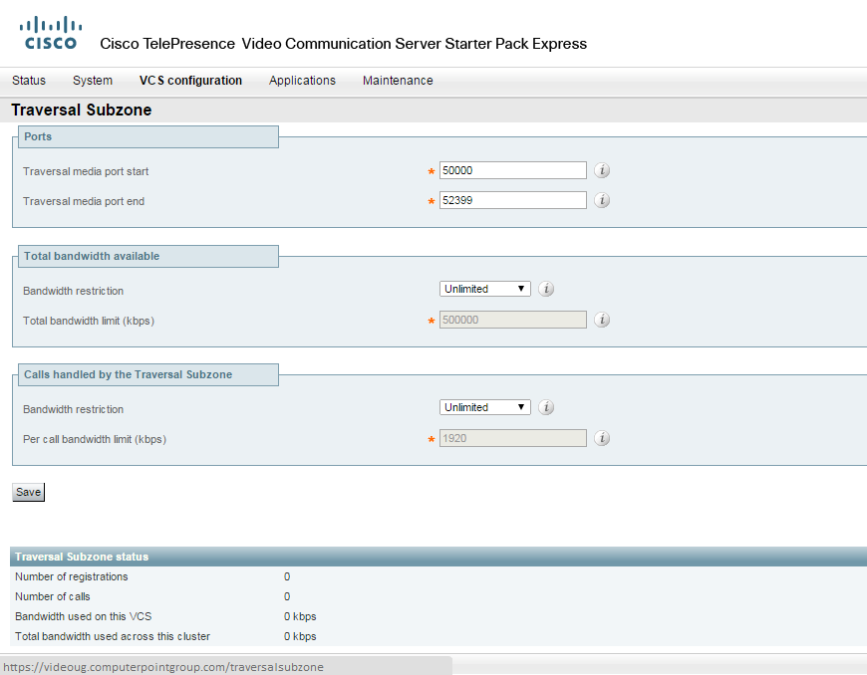
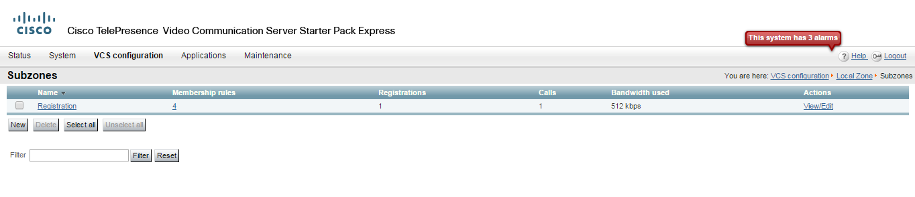
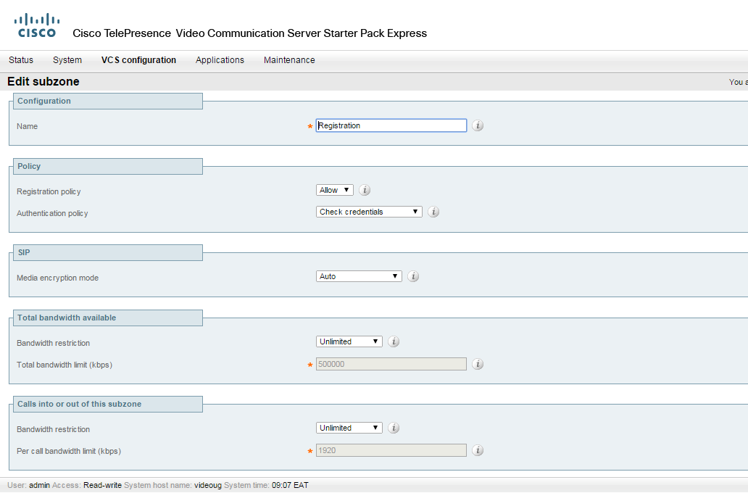

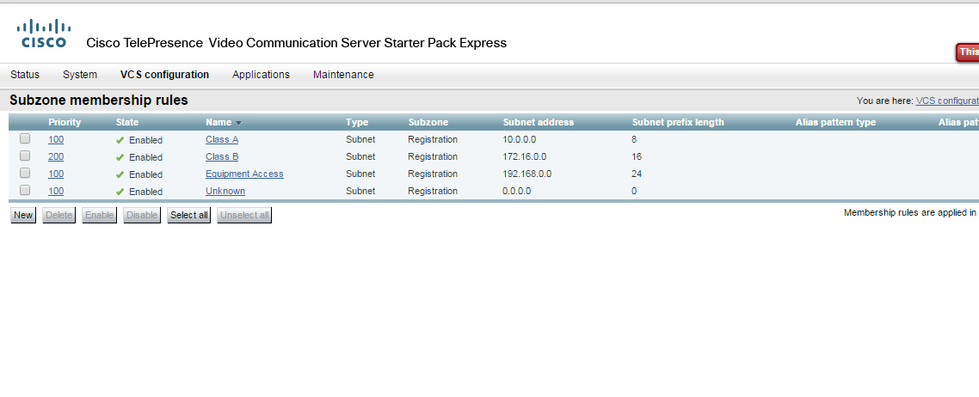

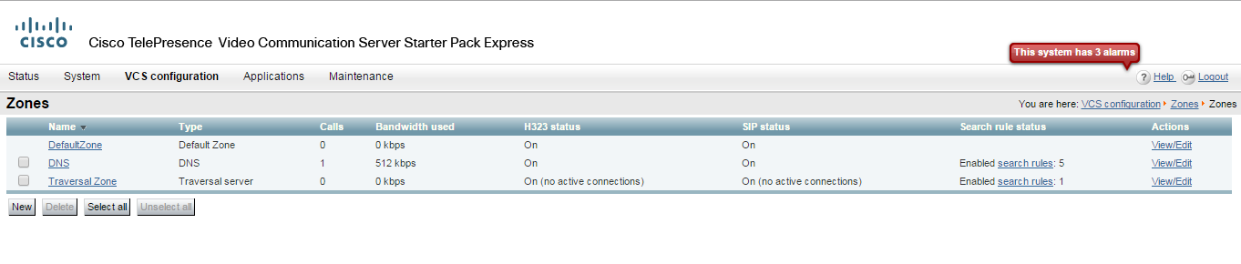
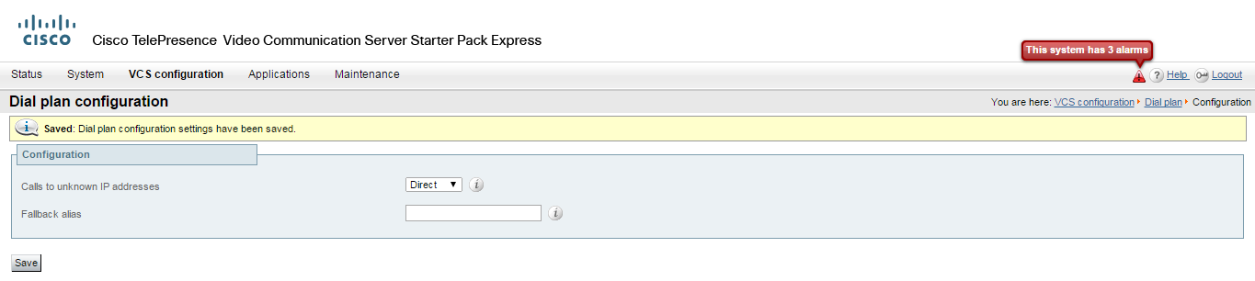
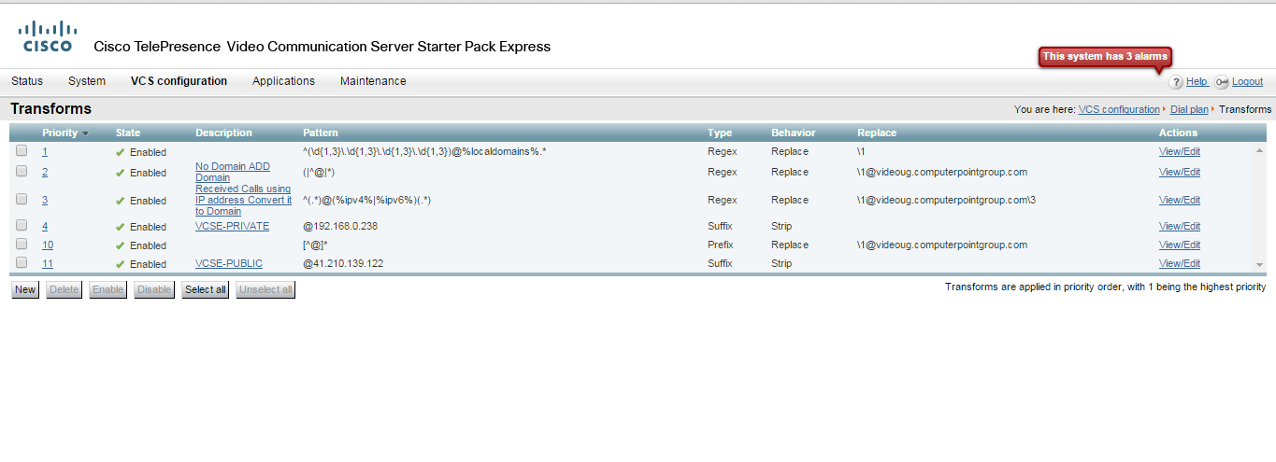
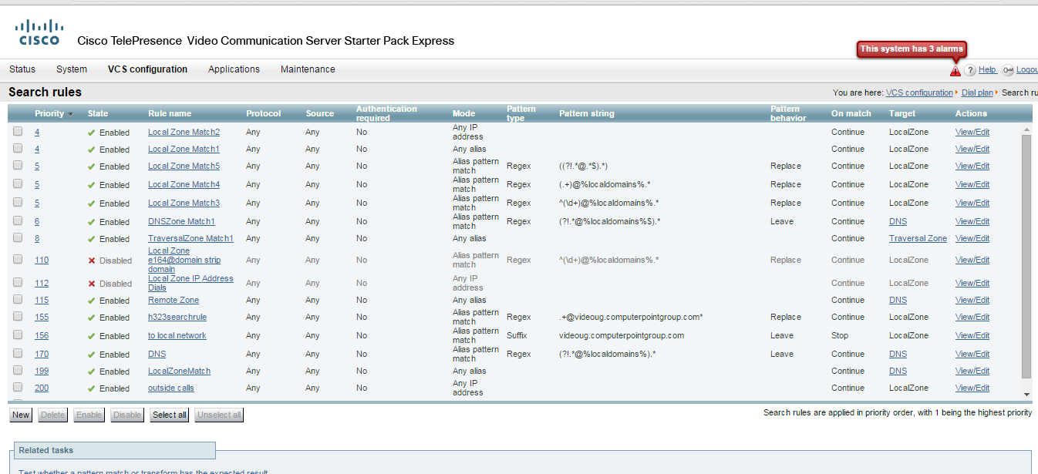

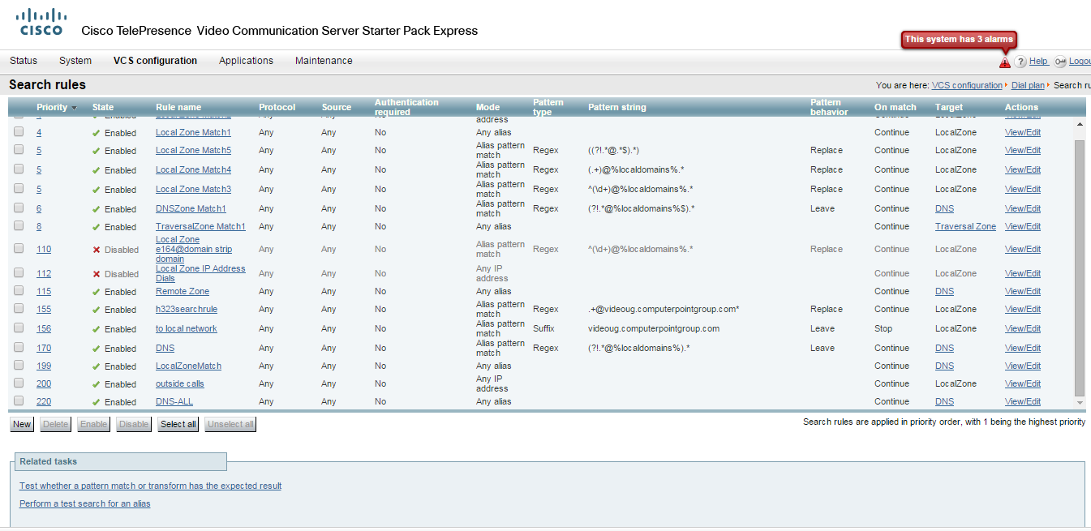

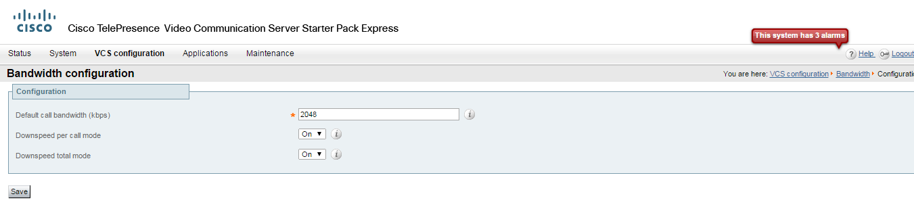

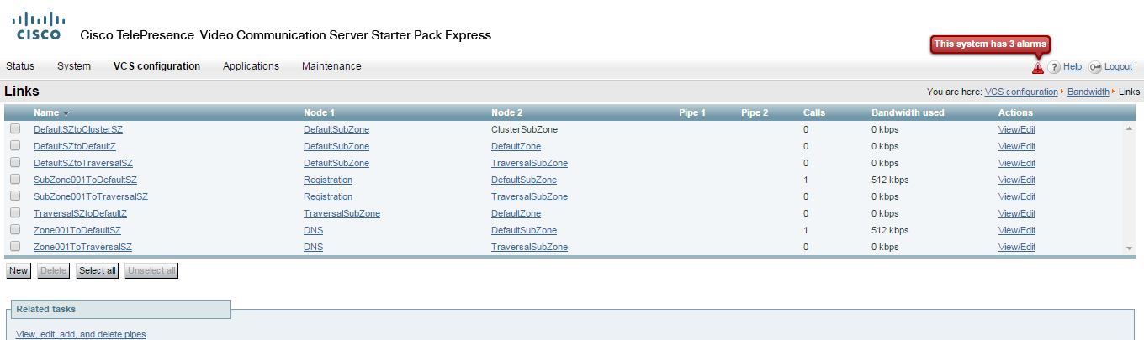

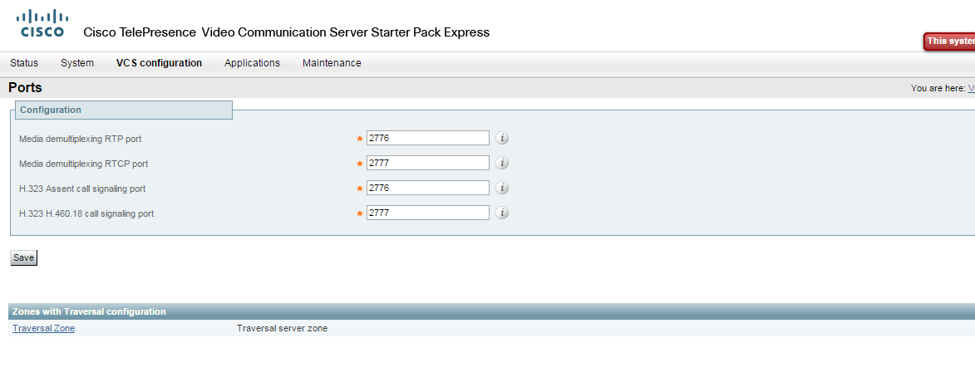

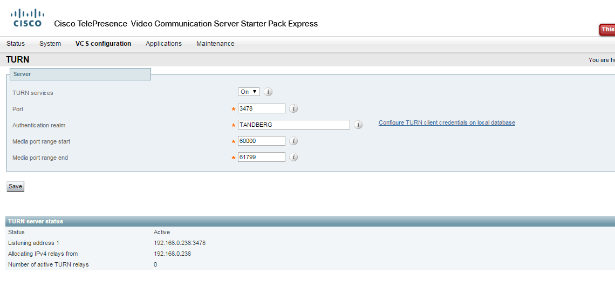

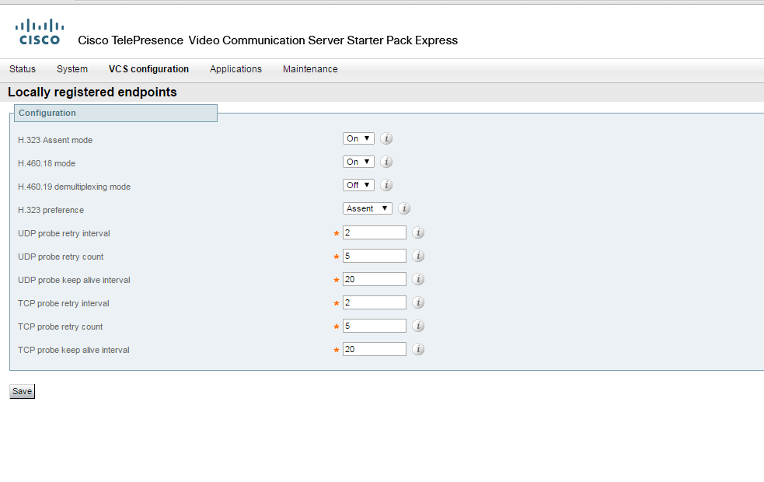
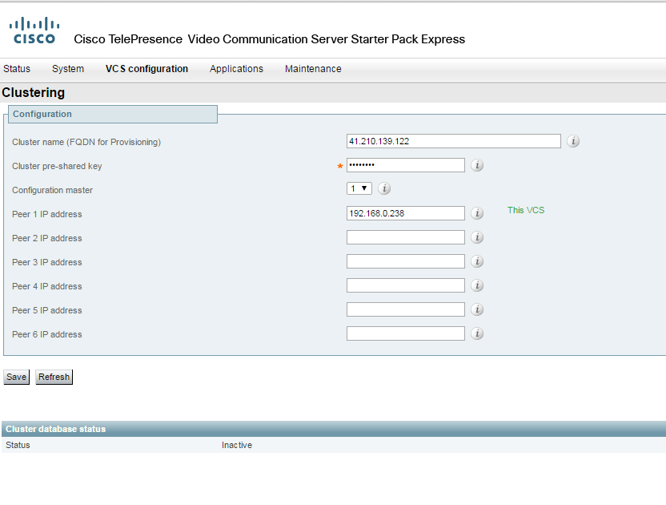

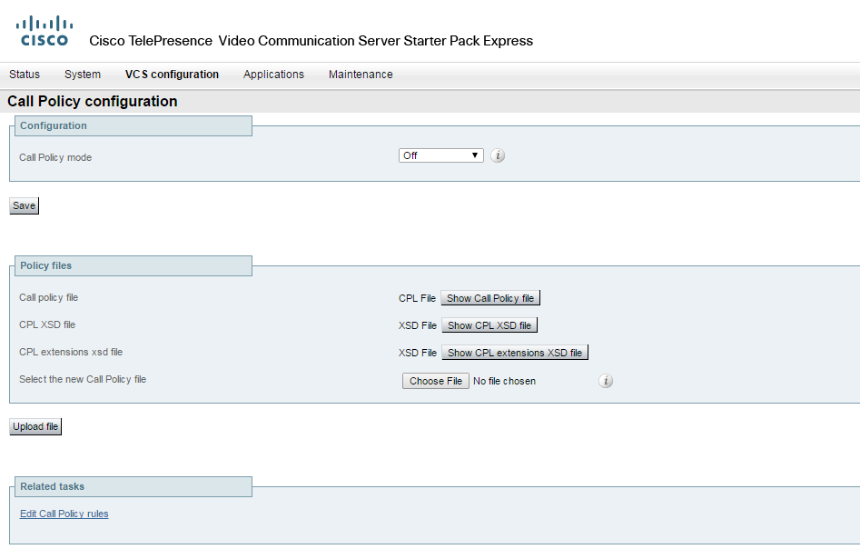
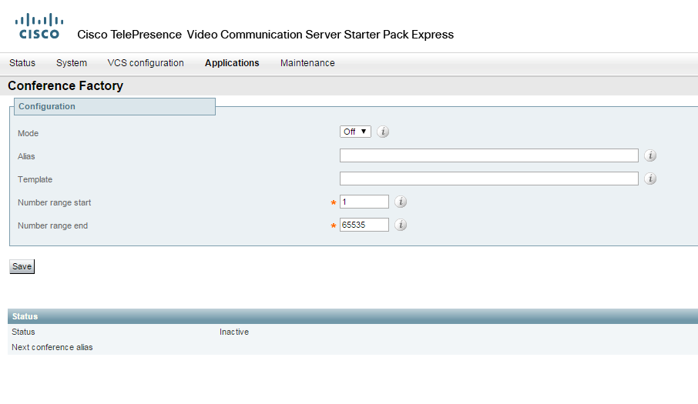
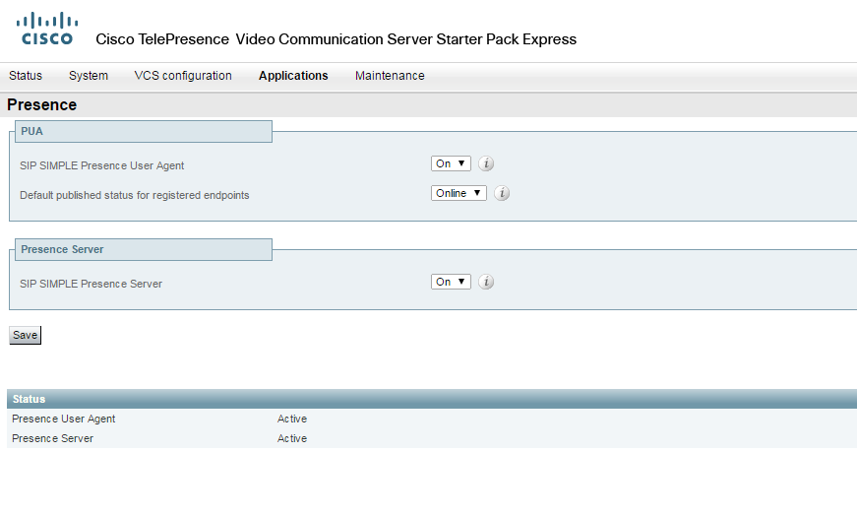
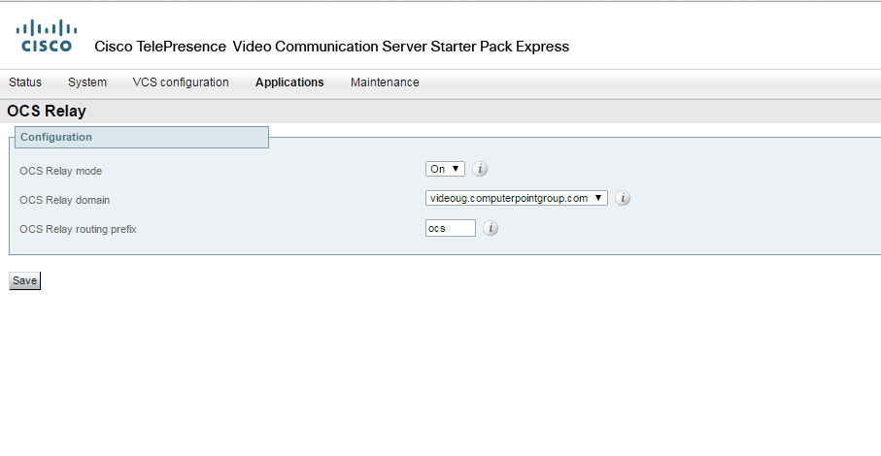
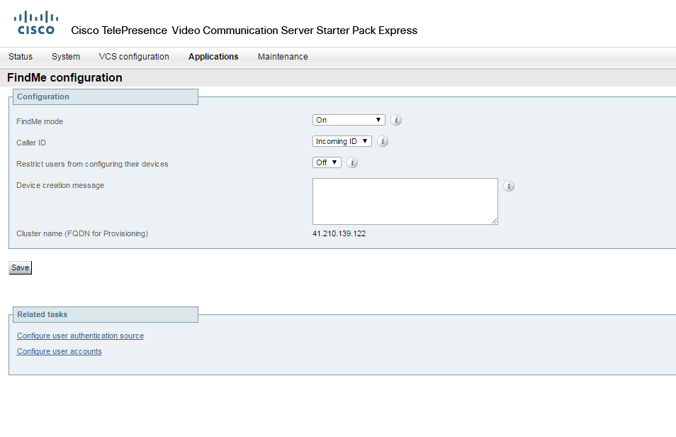
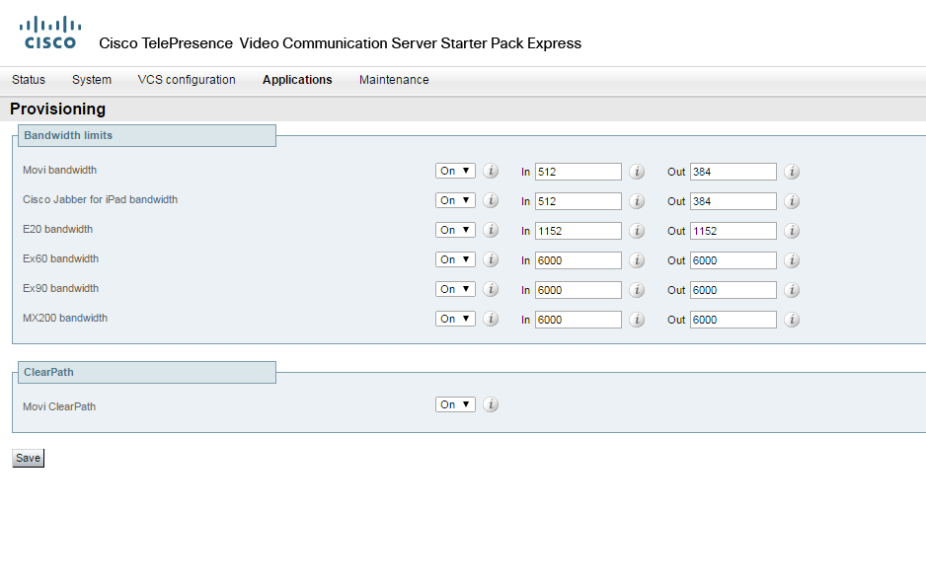
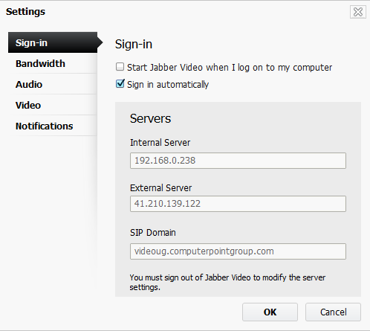

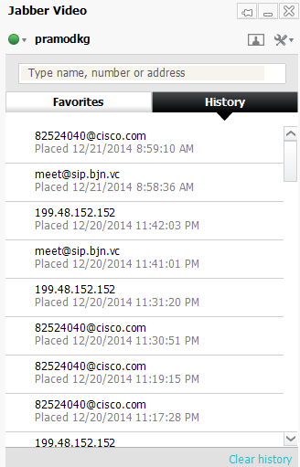
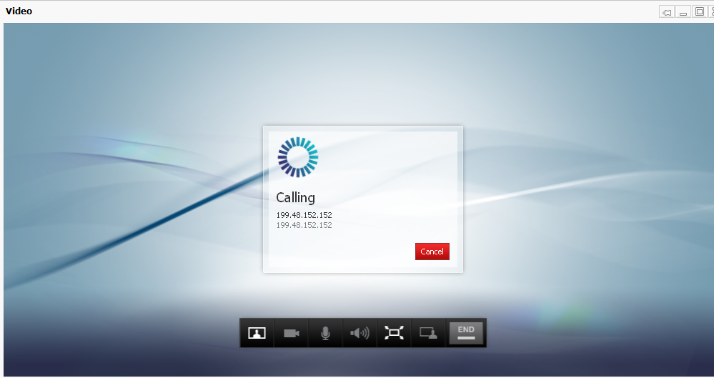

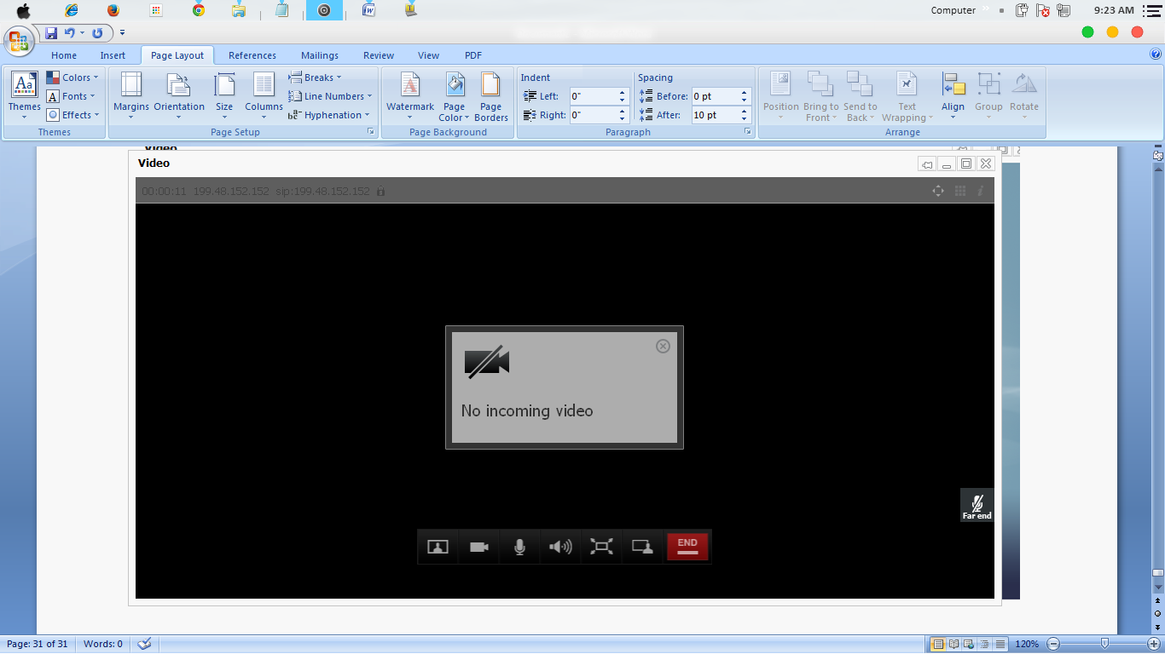

CLI COMMANDS

1 alarm:
* warning Insecure password in use - The root user's password is hashed using MD5, which is not secure enough

Welcome to videoug
TANDBERG VCS Release X7.2.3
SW Release Date: 2014-04-10

OK

xconfiguration
*c xConfiguration Login Remote Protocol: LDAP
*c xConfiguration Login Remote LDAP Server Address: ""
*c xConfiguration Login Remote LDAP Server FQDNResolution: AddressRecord
*c xConfiguration Login Remote LDAP Server Port: 389
*c xConfiguration Login Remote LDAP VCS BindUsername: ""
*c xConfiguration Login Remote LDAP VCS BindPassword: "{cipher}JCgLoc0VvpP+/AR37lHAuw=="
*c xConfiguration Login Remote LDAP VCS BindDN: ""
*c xConfiguration Login Remote LDAP BaseDN Accounts: ""
*c xConfiguration Login Remote LDAP BaseDN Groups: ""
*c xConfiguration Login Remote LDAP Encryption: Off
*c xConfiguration Login Remote LDAP SASL: DIGEST-MD5
*c xConfiguration Login Remote LDAP CRLCheck: None
*c xConfiguration Login Remote LDAP DirectoryType: ActiveDirectory
*c xConfiguration SystemUnit Name: "videoug"
*c xConfiguration SystemUnit Maintenance Mode: Off
*c xConfiguration Option 1 Key: "116341S00-1-C3318411"
*c xConfiguration Ethernet 1 Speed: Auto
*c xConfiguration Ethernet 1 IP V4 Address: "192.168.0.238"
*c xConfiguration Ethernet 1 IP V4 SubnetMask: "255.255.255.0"
*c xConfiguration Ethernet 1 IP V6 Address: ""
*c xConfiguration Ethernet 2 Speed: Auto
*c xConfiguration Ethernet 2 IP V4 Address: "127.0.0.1"
*c xConfiguration Ethernet 2 IP V4 SubnetMask: "255.255.255.255"
*c xConfiguration Ethernet 2 IP V6 Address: ""
*c xConfiguration IPProtocol: IPv4
*c xConfiguration IP Gateway: "192.168.0.241"
*c xConfiguration IP QoS Mode: DiffServ
*c xConfiguration IP QoS Value: 24
*c xConfiguration IP V6 Gateway: ""
*c xConfiguration IP DNS Domain Name: "videoug.computerpointgroup.com"
*c xConfiguration IP DNS Hostname: "videoug"
*c xConfiguration IP Ephemeral PortRange Start: 40000
*c xConfiguration IP Ephemeral PortRange End: 49999
*c xConfiguration IP RFC4821 Mode: Disabled
*c xConfiguration Administration Telnet Mode: On
*c xConfiguration Administration SSH Mode: On
*c xConfiguration Administration HTTP Mode: On
*c xConfiguration Administration HTTPS Mode: On
*c xConfiguration Administration LCDPanel Mode: On
*c xConfiguration ExternalManager Address: "192.168.0.223"
*c xConfiguration ExternalManager Path: "tms/public/external/management/systemmanagementservice.asmx"
*c xConfiguration ExternalManager Protocol: HTTPS
*c xConfiguration ExternalManager Server Certificate Verification Mode: On
*c xConfiguration Registration RestrictionPolicy Mode: None
*c xConfiguration Registration RestrictionPolicy Service Protocol: HTTPS
*c xConfiguration Registration RestrictionPolicy Service TLS Verify Mode: On
*c xConfiguration Registration RestrictionPolicy Service TLS CRLCheck Mode: Off
*c xConfiguration Registration RestrictionPolicy Service Server 1 Address: "10.1.1.10"
*c xConfiguration Registration RestrictionPolicy Service Server 2 Address: ""
*c xConfiguration Registration RestrictionPolicy Service Server 3 Address: ""
*c xConfiguration Registration RestrictionPolicy Service Path: ""
*c xConfiguration Registration RestrictionPolicy Service Status Path: "status"
*c xConfiguration Registration RestrictionPolicy Service UserName: "root"
*c xConfiguration Registration RestrictionPolicy Service Password: "{cipher}nvrqXstvBbRLIMxQkdpD5VwHG1GcOYgofMyiSO5m5A0="
*c xConfiguration Registration RestrictionPolicy Service DefaultCPL: "<reject status='403' reason='Service Unavailable'/>"
*c xConfiguration Alternates ConfigurationMaster: 1
*c xConfiguration Alternates Cluster Name: "41.210.139.122"
*c xConfiguration Alternates Peer 1 Address: "192.168.0.238"
*c xConfiguration Alternates Peer 2 Address: ""
*c xConfiguration Alternates Peer 3 Address: ""
*c xConfiguration Alternates Peer 4 Address: ""
*c xConfiguration Alternates Peer 5 Address: ""
*c xConfiguration Alternates Peer 6 Address: ""
*c xConfiguration Transform 1 Description: ""
*c xConfiguration Transform 1 State: Enabled
*c xConfiguration Transform 1 Priority: 10
*c xConfiguration Transform 1 Pattern String: "[^@]*"
*c xConfiguration Transform 1 Pattern Type: Prefix
*c xConfiguration Transform 1 Pattern Behavior: Replace
*c xConfiguration Transform 1 Pattern Replace: "\1@videoug.computerpointgroup.com"
*c xConfiguration Transform 2 Description: ""
*c xConfiguration Transform 2 State: Enabled
*c xConfiguration Transform 2 Priority: 1
*c xConfiguration Transform 2 Pattern String: "^(\d{1,3}\.\d{1,3}\.\d{1,3}\.\d{1,3})@%localdomains%.*"
*c xConfiguration Transform 2 Pattern Type: Regex
*c xConfiguration Transform 2 Pattern Behavior: Replace
*c xConfiguration Transform 2 Pattern Replace: "\1"
*c xConfiguration Transform 3 Description: "No Domain ADD Domain"
*c xConfiguration Transform 3 State: Enabled
*c xConfiguration Transform 3 Priority: 2
*c xConfiguration Transform 3 Pattern String: "(|^@|*)"
*c xConfiguration Transform 3 Pattern Type: Regex
*c xConfiguration Transform 3 Pattern Behavior: Replace
*c xConfiguration Transform 3 Pattern Replace: "\1@videoug.computerpointgroup.com"
*c xConfiguration Transform 4 Description: "Received Calls using IP address Convert it to Domain"
*c xConfiguration Transform 4 State: Enabled
*c xConfiguration Transform 4 Priority: 3
*c xConfiguration Transform 4 Pattern String: "^(.*)@(%ipv4%|%ipv6%)(.*)"
*c xConfiguration Transform 4 Pattern Type: Regex
*c xConfiguration Transform 4 Pattern Behavior: Replace
*c xConfiguration Transform 4 Pattern Replace: "\1@videoug.computerpointgroup.com\3"
*c xConfiguration Transform 5 Description: "VCSE-PRIVATE"
*c xConfiguration Transform 5 State: Enabled
*c xConfiguration Transform 5 Priority: 4
*c xConfiguration Transform 5 Pattern String: "@192.168.0.238"
*c xConfiguration Transform 5 Pattern Type: Suffix
*c xConfiguration Transform 5 Pattern Behavior: Strip
*c xConfiguration Transform 5 Pattern Replace: ""
*c xConfiguration Transform 6 Description: "VCSE-PUBLIC"
*c xConfiguration Transform 6 State: Enabled
*c xConfiguration Transform 6 Priority: 11
*c xConfiguration Transform 6 Pattern String: "@41.210.139.122"
*c xConfiguration Transform 6 Pattern Type: Suffix
*c xConfiguration Transform 6 Pattern Behavior: Strip
*c xConfiguration Transform 6 Pattern Replace: ""
*c xConfiguration Call Loop Detection Mode: On
*c xConfiguration Call Routed Mode: Always
*c xConfiguration Call Services CallsToUnknownIPAddresses: Direct
*c xConfiguration Call Services Fallback Alias: ""
*c xConfiguration H323 Mode: On
*c xConfiguration H323 Gatekeeper Registration UDP Port: 1719
*c xConfiguration H323 Gatekeeper Registration ConflictMode: Reject
*c xConfiguration H323 Gatekeeper CallSignaling TCP Port: 1720
*c xConfiguration H323 Gatekeeper CallSignaling PortRange Start: 15000
*c xConfiguration H323 Gatekeeper CallSignaling PortRange End: 19999
*c xConfiguration H323 Gatekeeper TimeToLive: 1800
*c xConfiguration H323 Gatekeeper CallTimeToLive: 120
*c xConfiguration H323 Gatekeeper AutoDiscovery Mode: On
*c xConfiguration H323 Gateway CallerId: ExcludePrefix
*c xConfiguration SIP Mode: On
*c xConfiguration SIP Domains Domain 1 Name: "videoug.computerpointgroup.com"
*c xConfiguration SIP Routes Route 1 Method: "SUBSCRIBE"
*c xConfiguration SIP Routes Route 1 Request Line Pattern: ".*@(%localdomains%|%ip%)"
*c xConfiguration SIP Routes Route 1 Header Name: "Event"
*c xConfiguration SIP Routes Route 1 Header Pattern: "phonebook.*"
*c xConfiguration SIP Routes Route 1 Authenticated: On
*c xConfiguration SIP Routes Route 1 Address: "127.0.0.1"
*c xConfiguration SIP Routes Route 1 Port: 22416
*c xConfiguration SIP Routes Route 1 Transport: UDP
*c xConfiguration SIP Routes Route 1 Tag: "VCSPhonebookServerSUB"
*c xConfiguration SIP Routes Route 2 Method: "INFO"
*c xConfiguration SIP Routes Route 2 Request Line Pattern: ".*@(%localdomains%|%ip%)"
*c xConfiguration SIP Routes Route 2 Header Name: "Content-Type"
*c xConfiguration SIP Routes Route 2 Header Pattern: "application/tandberg-phonebook\+xml"
*c xConfiguration SIP Routes Route 2 Authenticated: On
*c xConfiguration SIP Routes Route 2 Address: "127.0.0.1"
*c xConfiguration SIP Routes Route 2 Port: 22416
*c xConfiguration SIP Routes Route 2 Transport: UDP
*c xConfiguration SIP Routes Route 2 Tag: "VCSPhonebookServerINF"
*c xConfiguration SIP Routes Route 3 Method: "SUBSCRIBE"
*c xConfiguration SIP Routes Route 3 Request Line Pattern: ".*@(%localdomains%|%ip%)"
*c xConfiguration SIP Routes Route 3 Header Name: "Event"
*c xConfiguration SIP Routes Route 3 Header Pattern: "ua-profile.*"
*c xConfiguration SIP Routes Route 3 Authenticated: On
*c xConfiguration SIP Routes Route 3 Address: "127.0.0.1"
*c xConfiguration SIP Routes Route 3 Port: 22410
*c xConfiguration SIP Routes Route 3 Transport: UDP
*c xConfiguration SIP Routes Route 3 Tag: "VCSProvisioningServer"
*c xConfiguration SIP Registration Standard Refresh Strategy: Maximum
*c xConfiguration SIP Registration Standard Refresh Minimum: 45
*c xConfiguration SIP Registration Standard Refresh Maximum: 60
*c xConfiguration SIP Registration Outbound Refresh Strategy: Variable
*c xConfiguration SIP Registration Outbound Refresh Minimum: 300
*c xConfiguration SIP Registration Outbound Refresh Maximum: 3600
*c xConfiguration SIP Registration Outbound Flow Timer: 0
*c xConfiguration SIP Registration Proxy Mode: Off
*c xConfiguration SIP Registration Call Remove: No
*c xConfiguration SIP Session Refresh Value: 1800
*c xConfiguration SIP Session Refresh Minimum: 500
*c xConfiguration SIP UDP Mode: On
*c xConfiguration SIP UDP Port: 5060
*c xConfiguration SIP TCP Mode: On
*c xConfiguration SIP TCP Port: 5060
*c xConfiguration SIP TCP Outbound Port Start: 25000
*c xConfiguration SIP TCP Outbound Port End: 29999
*c xConfiguration SIP TLS Mode: On
*c xConfiguration SIP TLS Port: 5061
*c xConfiguration SIP TLS Certificate Revocation Checking Mode: Off
*c xConfiguration SIP TLS Certificate Revocation Checking OCSP Mode: On
*c xConfiguration SIP TLS Certificate Revocation Checking CRL Mode: On
*c xConfiguration SIP TLS Certificate Revocation Checking CRL Network Fetch Mode: On
*c xConfiguration SIP TLS Certificate Revocation Checking Source Inaccessibility Behavior: Fail
*c xConfiguration SIP Require UDP BFCP Mode: On
*c xConfiguration SIP Require Duo Video Mode: On
*c xConfiguration SIP Authentication Retry Limit: 3
*c xConfiguration SIP Authentication NTLM Mode: Auto
*c xConfiguration SIP Authentication NTLM SA Lifetime: 28800
*c xConfiguration SIP Authentication NTLM SA Limit: 10000
*c xConfiguration SIP Authentication Digest Nonce ExpireDelta: 300
*c xConfiguration SIP Authentication Digest Nonce Maximum Use Count: 128
*c xConfiguration SIP Authentication Digest Nonce Limit: 10000
*c xConfiguration SIP Authentication Digest Nonce Length: 60
*c xConfiguration SIP GRUU Mode: On
*c xConfiguration SIP MediaRouting ICE Mode: Off
*c xConfiguration Interworking Mode: RegisteredOnly
*c xConfiguration Interworking Encryption Mode: Auto
*c xConfiguration Interworking Encryption Replay Protection Mode: Off
*c xConfiguration Interworking BFCP Compatibility Mode: Auto
*c xConfiguration Interworking Require Invite Header Mode: On
*c xConfiguration Traversal Media Port Start: 50000
*c xConfiguration Traversal Media Port End: 52399
*c xConfiguration Traversal Server Media Demultiplexing RTP Port: 2776
*c xConfiguration Traversal Server Media Demultiplexing RTCP Port: 2777
*c xConfiguration Traversal Server H323 Assent CallSignaling Port: 2776
*c xConfiguration Traversal Server H323 H46018 CallSignaling Port: 2777
*c xConfiguration Traversal Server TURN Mode: On
*c xConfiguration Traversal Server TURN Port: 3478
*c xConfiguration Traversal Server TURN Authentication Realm: "TANDBERG"
*c xConfiguration Traversal Server TURN Media Port Start: 60000
*c xConfiguration Traversal Server TURN Media Port End: 61799
*c xConfiguration Authentication UserName: ""
*c xConfiguration Authentication Password: "{cipher}aN5PbyxP9VtFFqvK+E4Iuw=="
*c xConfiguration Authentication LDAP AliasOrigin: LDAP
*c xConfiguration Authentication ADS ADDomain: ""
*c xConfiguration Authentication ADS Workgroup: ""
*c xConfiguration Authentication ADS MachinePassword Refresh: On
*c xConfiguration Authentication ADS SPNEGO: Enabled
*c xConfiguration Authentication ADS SecureChannel: Auto
*c xConfiguration Authentication ADS Encryption: TLS
*c xConfiguration Authentication ADS Mode: Off
*c xConfiguration Authentication ADS Clockskew: 300
*c xConfiguration Zones Policy Mode: SearchRules
*c xConfiguration Zones Policy SearchRules Rule 1 Name: "LocalZoneMatch"
*c xConfiguration Zones Policy SearchRules Rule 1 Description: "Default rule: queries the Local Zone for any alias"
*c xConfiguration Zones Policy SearchRules Rule 1 Priority: 199
*c xConfiguration Zones Policy SearchRules Rule 1 Protocol: Any
*c xConfiguration Zones Policy SearchRules Rule 1 Source Mode: Any
*c xConfiguration Zones Policy SearchRules Rule 1 Authentication: No
*c xConfiguration Zones Policy SearchRules Rule 1 Mode: AnyAlias
*c xConfiguration Zones Policy SearchRules Rule 1 Progress: Continue
*c xConfiguration Zones Policy SearchRules Rule 1 Target Type: Zone
*c xConfiguration Zones Policy SearchRules Rule 1 Target Name: "DNS"
*c xConfiguration Zones Policy SearchRules Rule 1 State: Enabled
*c xConfiguration Zones Policy SearchRules Rule 2 Name: "h323searchrule"
*c xConfiguration Zones Policy SearchRules Rule 2 Description: ""
*c xConfiguration Zones Policy SearchRules Rule 2 Priority: 155
*c xConfiguration Zones Policy SearchRules Rule 2 Protocol: Any
*c xConfiguration Zones Policy SearchRules Rule 2 Source Mode: Any
*c xConfiguration Zones Policy SearchRules Rule 2 Authentication: No
*c xConfiguration Zones Policy SearchRules Rule 2 Mode: AliasPatternMatch
*c xConfiguration Zones Policy SearchRules Rule 2 Pattern Type: Regex
*c xConfiguration Zones Policy SearchRules Rule 2 Pattern String: ".+@videoug.computerpointgroup.com*"
*c xConfiguration Zones Policy SearchRules Rule 2 Pattern Behavior: Replace
*c xConfiguration Zones Policy SearchRules Rule 2 Pattern Replace: "\1"
*c xConfiguration Zones Policy SearchRules Rule 2 Progress: Continue
*c xConfiguration Zones Policy SearchRules Rule 2 Target Type: Zone
*c xConfiguration Zones Policy SearchRules Rule 2 Target Name: "LocalZone"
*c xConfiguration Zones Policy SearchRules Rule 2 State: Enabled
*c xConfiguration Zones Policy SearchRules Rule 3 Name: "outside calls"
*c xConfiguration Zones Policy SearchRules Rule 3 Description: "To call IPs"
*c xConfiguration Zones Policy SearchRules Rule 3 Priority: 200
*c xConfiguration Zones Policy SearchRules Rule 3 Protocol: Any
*c xConfiguration Zones Policy SearchRules Rule 3 Source Mode: Any
*c xConfiguration Zones Policy SearchRules Rule 3 Authentication: No
*c xConfiguration Zones Policy SearchRules Rule 3 Mode: AnyIPAddress
*c xConfiguration Zones Policy SearchRules Rule 3 Progress: Continue
*c xConfiguration Zones Policy SearchRules Rule 3 Target Type: Zone
*c xConfiguration Zones Policy SearchRules Rule 3 Target Name: "LocalZone"
*c xConfiguration Zones Policy SearchRules Rule 3 State: Enabled
*c xConfiguration Zones Policy SearchRules Rule 4 Name: "DNS"
*c xConfiguration Zones Policy SearchRules Rule 4 Description: ""
*c xConfiguration Zones Policy SearchRules Rule 4 Priority: 170
*c xConfiguration Zones Policy SearchRules Rule 4 Protocol: Any
*c xConfiguration Zones Policy SearchRules Rule 4 Source Mode: Any
*c xConfiguration Zones Policy SearchRules Rule 4 Authentication: No
*c xConfiguration Zones Policy SearchRules Rule 4 Mode: AliasPatternMatch
*c xConfiguration Zones Policy SearchRules Rule 4 Pattern Type: Regex
*c xConfiguration Zones Policy SearchRules Rule 4 Pattern String: "(?!.*@%localdomains%).*"
*c xConfiguration Zones Policy SearchRules Rule 4 Pattern Behavior: Leave
*c xConfiguration Zones Policy SearchRules Rule 4 Pattern Replace: ""
*c xConfiguration Zones Policy SearchRules Rule 4 Progress: Continue
*c xConfiguration Zones Policy SearchRules Rule 4 Target Type: Zone
*c xConfiguration Zones Policy SearchRules Rule 4 Target Name: "DNS"
*c xConfiguration Zones Policy SearchRules Rule 4 State: Enabled
*c xConfiguration Zones Policy SearchRules Rule 5 Name: "to local network"
*c xConfiguration Zones Policy SearchRules Rule 5 Description: ""
*c xConfiguration Zones Policy SearchRules Rule 5 Priority: 156
*c xConfiguration Zones Policy SearchRules Rule 5 Protocol: Any
*c xConfiguration Zones Policy SearchRules Rule 5 Source Mode: Any
*c xConfiguration Zones Policy SearchRules Rule 5 Authentication: No
*c xConfiguration Zones Policy SearchRules Rule 5 Mode: AliasPatternMatch
*c xConfiguration Zones Policy SearchRules Rule 5 Pattern Type: Suffix
*c xConfiguration Zones Policy SearchRules Rule 5 Pattern String: "videoug.computerpointgroup.com"
*c xConfiguration Zones Policy SearchRules Rule 5 Pattern Behavior: Leave
*c xConfiguration Zones Policy SearchRules Rule 5 Pattern Replace: ""
*c xConfiguration Zones Policy SearchRules Rule 5 Progress: Stop
*c xConfiguration Zones Policy SearchRules Rule 5 Target Type: Zone
*c xConfiguration Zones Policy SearchRules Rule 5 Target Name: "LocalZone"
*c xConfiguration Zones Policy SearchRules Rule 5 State: Enabled
*c xConfiguration Zones Policy SearchRules Rule 6 Name: "Local Zone e164@domain strip domain"
*c xConfiguration Zones Policy SearchRules Rule 6 Description: ""
*c xConfiguration Zones Policy SearchRules Rule 6 Priority: 110
*c xConfiguration Zones Policy SearchRules Rule 6 Protocol: Any
*c xConfiguration Zones Policy SearchRules Rule 6 Source Mode: Any
*c xConfiguration Zones Policy SearchRules Rule 6 Authentication: No
*c xConfiguration Zones Policy SearchRules Rule 6 Mode: AliasPatternMatch
*c xConfiguration Zones Policy SearchRules Rule 6 Pattern Type: Regex
*c xConfiguration Zones Policy SearchRules Rule 6 Pattern String: "^(\d+)@%localdomains%.*"
*c xConfiguration Zones Policy SearchRules Rule 6 Pattern Behavior: Replace
*c xConfiguration Zones Policy SearchRules Rule 6 Pattern Replace: "\1"
*c xConfiguration Zones Policy SearchRules Rule 6 Progress: Continue
*c xConfiguration Zones Policy SearchRules Rule 6 Target Type: Zone
*c xConfiguration Zones Policy SearchRules Rule 6 Target Name: "LocalZone"
*c xConfiguration Zones Policy SearchRules Rule 6 State: Disabled
*c xConfiguration Zones Policy SearchRules Rule 7 Name: "Remote Zone"
*c xConfiguration Zones Policy SearchRules Rule 7 Description: ""
*c xConfiguration Zones Policy SearchRules Rule 7 Priority: 115
*c xConfiguration Zones Policy SearchRules Rule 7 Protocol: Any
*c xConfiguration Zones Policy SearchRules Rule 7 Source Mode: Any
*c xConfiguration Zones Policy SearchRules Rule 7 Authentication: No
*c xConfiguration Zones Policy SearchRules Rule 7 Mode: AnyAlias
*c xConfiguration Zones Policy SearchRules Rule 7 Progress: Continue
*c xConfiguration Zones Policy SearchRules Rule 7 Target Type: Zone
*c xConfiguration Zones Policy SearchRules Rule 7 Target Name: "DNS"
*c xConfiguration Zones Policy SearchRules Rule 7 State: Enabled
*c xConfiguration Zones Policy SearchRules Rule 8 Name: "Local Zone IP Address Dials"
*c xConfiguration Zones Policy SearchRules Rule 8 Description: ""
*c xConfiguration Zones Policy SearchRules Rule 8 Priority: 112
*c xConfiguration Zones Policy SearchRules Rule 8 Protocol: Any
*c xConfiguration Zones Policy SearchRules Rule 8 Source Mode: Any
*c xConfiguration Zones Policy SearchRules Rule 8 Authentication: No
*c xConfiguration Zones Policy SearchRules Rule 8 Mode: AnyIPAddress
*c xConfiguration Zones Policy SearchRules Rule 8 Progress: Continue
*c xConfiguration Zones Policy SearchRules Rule 8 Target Type: Zone
*c xConfiguration Zones Policy SearchRules Rule 8 Target Name: "LocalZone"
*c xConfiguration Zones Policy SearchRules Rule 8 State: Disabled
*c xConfiguration Zones Policy SearchRules Rule 9 Name: "DNS-ALL"
*c xConfiguration Zones Policy SearchRules Rule 9 Description: ""
*c xConfiguration Zones Policy SearchRules Rule 9 Priority: 220
*c xConfiguration Zones Policy SearchRules Rule 9 Protocol: Any
*c xConfiguration Zones Policy SearchRules Rule 9 Source Mode: Any
*c xConfiguration Zones Policy SearchRules Rule 9 Authentication: No
*c xConfiguration Zones Policy SearchRules Rule 9 Mode: AnyAlias
*c xConfiguration Zones Policy SearchRules Rule 9 Progress: Continue
*c xConfiguration Zones Policy SearchRules Rule 9 Target Type: Zone
*c xConfiguration Zones Policy SearchRules Rule 9 Target Name: "DNS"
*c xConfiguration Zones Policy SearchRules Rule 9 State: Enabled
*c xConfiguration Zones Policy SearchRules Rule 10 Name: "Local Zone Match1"
*c xConfiguration Zones Policy SearchRules Rule 10 Description: ""
*c xConfiguration Zones Policy SearchRules Rule 10 Priority: 4
*c xConfiguration Zones Policy SearchRules Rule 10 Protocol: Any
*c xConfiguration Zones Policy SearchRules Rule 10 Source Mode: Any
*c xConfiguration Zones Policy SearchRules Rule 10 Authentication: No
*c xConfiguration Zones Policy SearchRules Rule 10 Mode: AnyAlias
*c xConfiguration Zones Policy SearchRules Rule 10 Progress: Continue
*c xConfiguration Zones Policy SearchRules Rule 10 Target Type: Zone
*c xConfiguration Zones Policy SearchRules Rule 10 Target Name: "LocalZone"
*c xConfiguration Zones Policy SearchRules Rule 10 State: Enabled
*c xConfiguration Zones Policy SearchRules Rule 11 Name: "Local Zone Match2"
*c xConfiguration Zones Policy SearchRules Rule 11 Description: ""
*c xConfiguration Zones Policy SearchRules Rule 11 Priority: 4
*c xConfiguration Zones Policy SearchRules Rule 11 Protocol: Any
*c xConfiguration Zones Policy SearchRules Rule 11 Source Mode: Any
*c xConfiguration Zones Policy SearchRules Rule 11 Authentication: No
*c xConfiguration Zones Policy SearchRules Rule 11 Mode: AnyIPAddress
*c xConfiguration Zones Policy SearchRules Rule 11 Progress: Continue
*c xConfiguration Zones Policy SearchRules Rule 11 Target Type: Zone
*c xConfiguration Zones Policy SearchRules Rule 11 Target Name: "LocalZone"
*c xConfiguration Zones Policy SearchRules Rule 11 State: Enabled
*c xConfiguration Zones Policy SearchRules Rule 12 Name: "Local Zone Match3"
*c xConfiguration Zones Policy SearchRules Rule 12 Description: ""
*c xConfiguration Zones Policy SearchRules Rule 12 Priority: 5
*c xConfiguration Zones Policy SearchRules Rule 12 Protocol: Any
*c xConfiguration Zones Policy SearchRules Rule 12 Source Mode: Any
*c xConfiguration Zones Policy SearchRules Rule 12 Authentication: No
*c xConfiguration Zones Policy SearchRules Rule 12 Mode: AliasPatternMatch
*c xConfiguration Zones Policy SearchRules Rule 12 Pattern Type: Regex
*c xConfiguration Zones Policy SearchRules Rule 12 Pattern String: "^(\d+)@%localdomains%.*"
*c xConfiguration Zones Policy SearchRules Rule 12 Pattern Behavior: Replace
*c xConfiguration Zones Policy SearchRules Rule 12 Pattern Replace: "\1"
*c xConfiguration Zones Policy SearchRules Rule 12 Progress: Continue
*c xConfiguration Zones Policy SearchRules Rule 12 Target Type: Zone
*c xConfiguration Zones Policy SearchRules Rule 12 Target Name: "LocalZone"
*c xConfiguration Zones Policy SearchRules Rule 12 State: Enabled
*c xConfiguration Zones Policy SearchRules Rule 13 Name: "Local Zone Match4"
*c xConfiguration Zones Policy SearchRules Rule 13 Description: ""
*c xConfiguration Zones Policy SearchRules Rule 13 Priority: 5
*c xConfiguration Zones Policy SearchRules Rule 13 Protocol: Any
*c xConfiguration Zones Policy SearchRules Rule 13 Source Mode: Any
*c xConfiguration Zones Policy SearchRules Rule 13 Authentication: No
*c xConfiguration Zones Policy SearchRules Rule 13 Mode: AliasPatternMatch
*c xConfiguration Zones Policy SearchRules Rule 13 Pattern Type: Regex
*c xConfiguration Zones Policy SearchRules Rule 13 Pattern String: "(.+)@%localdomains%.*"
*c xConfiguration Zones Policy SearchRules Rule 13 Pattern Behavior: Replace
*c xConfiguration Zones Policy SearchRules Rule 13 Pattern Replace: "\1"
*c xConfiguration Zones Policy SearchRules Rule 13 Progress: Continue
*c xConfiguration Zones Policy SearchRules Rule 13 Target Type: Zone
*c xConfiguration Zones Policy SearchRules Rule 13 Target Name: "LocalZone"
*c xConfiguration Zones Policy SearchRules Rule 13 State: Enabled
*c xConfiguration Zones Policy SearchRules Rule 14 Name: "Local Zone Match5"
*c xConfiguration Zones Policy SearchRules Rule 14 Description: ""
*c xConfiguration Zones Policy SearchRules Rule 14 Priority: 5
*c xConfiguration Zones Policy SearchRules Rule 14 Protocol: Any
*c xConfiguration Zones Policy SearchRules Rule 14 Source Mode: Any
*c xConfiguration Zones Policy SearchRules Rule 14 Authentication: No
*c xConfiguration Zones Policy SearchRules Rule 14 Mode: AliasPatternMatch
*c xConfiguration Zones Policy SearchRules Rule 14 Pattern Type: Regex
*c xConfiguration Zones Policy SearchRules Rule 14 Pattern String: "((?!.*@.*$).*)"
*c xConfiguration Zones Policy SearchRules Rule 14 Pattern Behavior: Replace
*c xConfiguration Zones Policy SearchRules Rule 14 Pattern Replace: "\1@videoug.computerpointgroup.com"
*c xConfiguration Zones Policy SearchRules Rule 14 Progress: Continue
*c xConfiguration Zones Policy SearchRules Rule 14 Target Type: Zone
*c xConfiguration Zones Policy SearchRules Rule 14 Target Name: "LocalZone"
*c xConfiguration Zones Policy SearchRules Rule 14 State: Enabled
*c xConfiguration Zones Policy SearchRules Rule 15 Name: "DNSZone Match1"
*c xConfiguration Zones Policy SearchRules Rule 15 Description: ""
*c xConfiguration Zones Policy SearchRules Rule 15 Priority: 6
*c xConfiguration Zones Policy SearchRules Rule 15 Protocol: Any
*c xConfiguration Zones Policy SearchRules Rule 15 Source Mode: Any
*c xConfiguration Zones Policy SearchRules Rule 15 Authentication: No
*c xConfiguration Zones Policy SearchRules Rule 15 Mode: AliasPatternMatch
*c xConfiguration Zones Policy SearchRules Rule 15 Pattern Type: Regex
*c xConfiguration Zones Policy SearchRules Rule 15 Pattern String: "(?!.*@%localdomains%$).*"
*c xConfiguration Zones Policy SearchRules Rule 15 Pattern Behavior: Leave
*c xConfiguration Zones Policy SearchRules Rule 15 Pattern Replace: ""
*c xConfiguration Zones Policy SearchRules Rule 15 Progress: Continue
*c xConfiguration Zones Policy SearchRules Rule 15 Target Type: Zone
*c xConfiguration Zones Policy SearchRules Rule 15 Target Name: "DNS"
*c xConfiguration Zones Policy SearchRules Rule 15 State: Enabled
*c xConfiguration Zones Policy SearchRules Rule 16 Name: "TraversalZone Match1"
*c xConfiguration Zones Policy SearchRules Rule 16 Description: ""
*c xConfiguration Zones Policy SearchRules Rule 16 Priority: 8
*c xConfiguration Zones Policy SearchRules Rule 16 Protocol: Any
*c xConfiguration Zones Policy SearchRules Rule 16 Source Mode: Any
*c xConfiguration Zones Policy SearchRules Rule 16 Authentication: No
*c xConfiguration Zones Policy SearchRules Rule 16 Mode: AnyAlias
*c xConfiguration Zones Policy SearchRules Rule 16 Progress: Continue
*c xConfiguration Zones Policy SearchRules Rule 16 Target Type: Zone
*c xConfiguration Zones Policy SearchRules Rule 16 Target Name: "Traversal Zone"
*c xConfiguration Zones Policy SearchRules Rule 16 State: Enabled
*c xConfiguration Zones DefaultZone Authentication Mode: CheckCredentials
*c xConfiguration Zones DefaultZone SIP Record Route Address Type: IP
*c xConfiguration Zones DefaultZone SIP TLS Verify Mode: Off
*c xConfiguration Zones DefaultZone SIP Media Encryption Mode: Auto
*c xConfiguration Zones LocalZone DefaultSubZone SIP Media Encryption Mode: Auto
*c xConfiguration Zones LocalZone DefaultSubZone Authentication Mode: CheckCredentials
*c xConfiguration Zones LocalZone DefaultSubZone Registrations: Allow
*c xConfiguration Zones LocalZone DefaultSubZone Bandwidth Total Mode: Unlimited
*c xConfiguration Zones LocalZone DefaultSubZone Bandwidth PerCall Inter Mode: Unlimited
*c xConfiguration Zones LocalZone DefaultSubZone Bandwidth PerCall Intra Mode: Unlimited
*c xConfiguration Zones LocalZone TraversalSubZone Bandwidth Total Mode: Unlimited
*c xConfiguration Zones LocalZone TraversalSubZone Bandwidth PerCall Mode: Unlimited
*c xConfiguration Zones LocalZone SIP Record Route Address Type: IP
*c xConfiguration Zones LocalZone SubZones SubZone 1 Name: "Registration"
*c xConfiguration Zones LocalZone SubZones SubZone 1 SIP Media Encryption Mode: Auto
*c xConfiguration Zones LocalZone SubZones SubZone 1 Authentication Mode: CheckCredentials
*c xConfiguration Zones LocalZone SubZones SubZone 1 Registrations: Allow
*c xConfiguration Zones LocalZone SubZones SubZone 1 Bandwidth Total Mode: Unlimited
*c xConfiguration Zones LocalZone SubZones SubZone 1 Bandwidth PerCall Inter Mode: Unlimited
*c xConfiguration Zones LocalZone SubZones SubZone 1 Bandwidth PerCall Intra Mode: Unlimited
*c xConfiguration Zones LocalZone SubZones MembershipRules Rule 1 Name: "Equipment Access"
*c xConfiguration Zones LocalZone SubZones MembershipRules Rule 1 Description: "try this"
*c xConfiguration Zones LocalZone SubZones MembershipRules Rule 1 Priority: 100
*c xConfiguration Zones LocalZone SubZones MembershipRules Rule 1 Type: Subnet
*c xConfiguration Zones LocalZone SubZones MembershipRules Rule 1 Subnet Address: "192.168.0.0"
*c xConfiguration Zones LocalZone SubZones MembershipRules Rule 1 Subnet PrefixLength: 24
*c xConfiguration Zones LocalZone SubZones MembershipRules Rule 1 Pattern Type: Prefix
*c xConfiguration Zones LocalZone SubZones MembershipRules Rule 1 Pattern String: ""
*c xConfiguration Zones LocalZone SubZones MembershipRules Rule 1 SubZoneName: "Registration"
*c xConfiguration Zones LocalZone SubZones MembershipRules Rule 1 State: Enabled
*c xConfiguration Zones LocalZone SubZones MembershipRules Rule 2 Name: "Class A"
*c xConfiguration Zones LocalZone SubZones MembershipRules Rule 2 Description: ""
*c xConfiguration Zones LocalZone SubZones MembershipRules Rule 2 Priority: 100
*c xConfiguration Zones LocalZone SubZones MembershipRules Rule 2 Type: Subnet
*c xConfiguration Zones LocalZone SubZones MembershipRules Rule 2 Subnet Address: "10.0.0.0"
*c xConfiguration Zones LocalZone SubZones MembershipRules Rule 2 Subnet PrefixLength: 8
*c xConfiguration Zones LocalZone SubZones MembershipRules Rule 2 Pattern Type: Prefix
*c xConfiguration Zones LocalZone SubZones MembershipRules Rule 2 Pattern String: ""
*c xConfiguration Zones LocalZone SubZones MembershipRules Rule 2 SubZoneName: "Registration"
*c xConfiguration Zones LocalZone SubZones MembershipRules Rule 2 State: Enabled
*c xConfiguration Zones LocalZone SubZones MembershipRules Rule 3 Name: "Class B"
*c xConfiguration Zones LocalZone SubZones MembershipRules Rule 3 Description: ""
*c xConfiguration Zones LocalZone SubZones MembershipRules Rule 3 Priority: 200
*c xConfiguration Zones LocalZone SubZones MembershipRules Rule 3 Type: Subnet
*c xConfiguration Zones LocalZone SubZones MembershipRules Rule 3 Subnet Address: "172.16.0.0"
*c xConfiguration Zones LocalZone SubZones MembershipRules Rule 3 Subnet PrefixLength: 16
*c xConfiguration Zones LocalZone SubZones MembershipRules Rule 3 Pattern Type: Prefix
*c xConfiguration Zones LocalZone SubZones MembershipRules Rule 3 Pattern String: ""
*c xConfiguration Zones LocalZone SubZones MembershipRules Rule 3 SubZoneName: "Registration"
*c xConfiguration Zones LocalZone SubZones MembershipRules Rule 3 State: Enabled
*c xConfiguration Zones LocalZone SubZones MembershipRules Rule 4 Name: "Unknown"
*c xConfiguration Zones LocalZone SubZones MembershipRules Rule 4 Description: ""
*c xConfiguration Zones LocalZone SubZones MembershipRules Rule 4 Priority: 100
*c xConfiguration Zones LocalZone SubZones MembershipRules Rule 4 Type: Subnet
*c xConfiguration Zones LocalZone SubZones MembershipRules Rule 4 Subnet Address: "0.0.0.0"
*c xConfiguration Zones LocalZone SubZones MembershipRules Rule 4 Subnet PrefixLength: 0
*c xConfiguration Zones LocalZone SubZones MembershipRules Rule 4 Pattern Type: Prefix
*c xConfiguration Zones LocalZone SubZones MembershipRules Rule 4 Pattern String: ""
*c xConfiguration Zones LocalZone SubZones MembershipRules Rule 4 SubZoneName: "Registration"
*c xConfiguration Zones LocalZone SubZones MembershipRules Rule 4 State: Enabled
*c xConfiguration Zones LocalZone Traversal H323 Assent Mode: On
*c xConfiguration Zones LocalZone Traversal H323 H46018 Mode: On
*c xConfiguration Zones LocalZone Traversal H323 H46019 Demultiplexing Mode: Off
*c xConfiguration Zones LocalZone Traversal H323 Preference: Assent
*c xConfiguration Zones LocalZone Traversal H323 UDPProbe RetryInterval: 2
*c xConfiguration Zones LocalZone Traversal H323 UDPProbe RetryCount: 5
*c xConfiguration Zones LocalZone Traversal H323 UDPProbe KeepAliveInterval: 20
*c xConfiguration Zones LocalZone Traversal H323 TCPProbe RetryInterval: 2
*c xConfiguration Zones LocalZone Traversal H323 TCPProbe RetryCount: 5
*c xConfiguration Zones LocalZone Traversal H323 TCPProbe KeepAliveInterval: 20
*c xConfiguration Zones Zone 1 Name: "DNS"
*c xConfiguration Zones Zone 1 HopCount: 15
*c xConfiguration Zones Zone 1 H323 Mode: On
*c xConfiguration Zones Zone 1 SIP Mode: On
*c xConfiguration Zones Zone 1 Type: DNS
*c xConfiguration Zones Zone 1 DNS IncludeAddressRecord: Off
*c xConfiguration Zones Zone 1 DNS ZoneProfile: Default
*c xConfiguration Zones Zone 1 DNS SIP TLS Verify Mode: Off
*c xConfiguration Zones Zone 1 DNS SIP TLS Verify Subject Name: ""
*c xConfiguration Zones Zone 1 DNS SIP Media Encryption Mode: Auto
*c xConfiguration Zones Zone 2 Name: "Traversal Zone"
*c xConfiguration Zones Zone 2 HopCount: 15
*c xConfiguration Zones Zone 2 H323 Mode: On
*c xConfiguration Zones Zone 2 SIP Mode: On
*c xConfiguration Zones Zone 2 Type: TraversalServer
*c xConfiguration Zones Zone 2 TraversalServer Authentication Mode: TreatAsAuthenticated
*c xConfiguration Zones Zone 2 TraversalServer Authentication UserName: "admin"
*c xConfiguration Zones Zone 2 TraversalServer Registrations: Allow
*c xConfiguration Zones Zone 2 TraversalServer UDPProbe RetryInterval: 2
*c xConfiguration Zones Zone 2 TraversalServer UDPProbe RetryCount: 5
*c xConfiguration Zones Zone 2 TraversalServer UDPProbe KeepAliveInterval: 20
*c xConfiguration Zones Zone 2 TraversalServer TCPProbe RetryInterval: 2
*c xConfiguration Zones Zone 2 TraversalServer TCPProbe RetryCount: 5
*c xConfiguration Zones Zone 2 TraversalServer TCPProbe KeepAliveInterval: 20
*c xConfiguration Zones Zone 2 TraversalServer H323 Protocol: Assent
*c xConfiguration Zones Zone 2 TraversalServer H323 H46019 Demultiplexing Mode: Off
*c xConfiguration Zones Zone 2 TraversalServer H323 Port: 6002
*c xConfiguration Zones Zone 2 TraversalServer SIP Protocol: Assent
*c xConfiguration Zones Zone 2 TraversalServer SIP Port: 7002
*c xConfiguration Zones Zone 2 TraversalServer SIP Transport: TLS
*c xConfiguration Zones Zone 2 TraversalServer SIP TLS Verify Mode: Off
*c xConfiguration Zones Zone 2 TraversalServer SIP TLS Verify Subject Name: ""
*c xConfiguration Zones Zone 2 TraversalServer SIP Poison Mode: Off
*c xConfiguration Zones Zone 2 TraversalServer SIP Media Encryption Mode: Auto
*c xConfiguration Bandwidth Default: 2048
*c xConfiguration Bandwidth Downspeed PerCall Mode: On
*c xConfiguration Bandwidth Downspeed Total Mode: On
*c xConfiguration Bandwidth Link 1 Name: "DefaultSZtoTraversalSZ"
*c xConfiguration Bandwidth Link 1 Node1 Name: "DefaultSubZone"
*c xConfiguration Bandwidth Link 1 Node2 Name: "TraversalSubZone"
*c xConfiguration Bandwidth Link 1 Pipe1 Name: ""
*c xConfiguration Bandwidth Link 1 Pipe2 Name: ""
*c xConfiguration Bandwidth Link 2 Name: "DefaultSZtoDefaultZ"
*c xConfiguration Bandwidth Link 2 Node1 Name: "DefaultSubZone"
*c xConfiguration Bandwidth Link 2 Node2 Name: "DefaultZone"
*c xConfiguration Bandwidth Link 2 Pipe1 Name: ""
*c xConfiguration Bandwidth Link 2 Pipe2 Name: ""
*c xConfiguration Bandwidth Link 3 Name: "DefaultSZtoClusterSZ"
*c xConfiguration Bandwidth Link 3 Node1 Name: "DefaultSubZone"
*c xConfiguration Bandwidth Link 3 Node2 Name: "ClusterSubZone"
*c xConfiguration Bandwidth Link 3 Pipe1 Name: ""
*c xConfiguration Bandwidth Link 3 Pipe2 Name: ""
*c xConfiguration Bandwidth Link 4 Name: "TraversalSZtoDefaultZ"
*c xConfiguration Bandwidth Link 4 Node1 Name: "TraversalSubZone"
*c xConfiguration Bandwidth Link 4 Node2 Name: "DefaultZone"
*c xConfiguration Bandwidth Link 4 Pipe1 Name: ""
*c xConfiguration Bandwidth Link 4 Pipe2 Name: ""
*c xConfiguration Bandwidth Link 5 Name: "SubZone001ToDefaultSZ"
*c xConfiguration Bandwidth Link 5 Node1 Name: "Registration"
*c xConfiguration Bandwidth Link 5 Node2 Name: "DefaultSubZone"
*c xConfiguration Bandwidth Link 5 Pipe1 Name: ""
*c xConfiguration Bandwidth Link 5 Pipe2 Name: ""
*c xConfiguration Bandwidth Link 6 Name: "SubZone001ToTraversalSZ"
*c xConfiguration Bandwidth Link 6 Node1 Name: "Registration"
*c xConfiguration Bandwidth Link 6 Node2 Name: "TraversalSubZone"
*c xConfiguration Bandwidth Link 6 Pipe1 Name: ""
*c xConfiguration Bandwidth Link 6 Pipe2 Name: ""
*c xConfiguration Bandwidth Link 7 Name: "Zone001ToDefaultSZ"
*c xConfiguration Bandwidth Link 7 Node1 Name: "DNS"
*c xConfiguration Bandwidth Link 7 Node2 Name: "DefaultSubZone"
*c xConfiguration Bandwidth Link 7 Pipe1 Name: ""
*c xConfiguration Bandwidth Link 7 Pipe2 Name: ""
*c xConfiguration Bandwidth Link 8 Name: "Zone001ToTraversalSZ"
*c xConfiguration Bandwidth Link 8 Node1 Name: "DNS"
*c xConfiguration Bandwidth Link 8 Node2 Name: "TraversalSubZone"
*c xConfiguration Bandwidth Link 8 Pipe1 Name: ""
*c xConfiguration Bandwidth Link 8 Pipe2 Name: ""
*c xConfiguration Policy AdministratorPolicy Mode: Off
*c xConfiguration Policy AdministratorPolicy Service Protocol: HTTP
*c xConfiguration Policy AdministratorPolicy Service TLS Verify Mode: On
*c xConfiguration Policy AdministratorPolicy Service TLS CRLCheck Mode: Off
*c xConfiguration Policy AdministratorPolicy Service Server 1 Address: ""
*c xConfiguration Policy AdministratorPolicy Service Server 2 Address: ""
*c xConfiguration Policy AdministratorPolicy Service Server 3 Address: ""
*c xConfiguration Policy AdministratorPolicy Service Path: ""
*c xConfiguration Policy AdministratorPolicy Service Status Path: "status"
*c xConfiguration Policy AdministratorPolicy Service UserName: ""
*c xConfiguration Policy AdministratorPolicy Service Password: "{cipher}xi9qq30gmlIqlXElvYCV9TwZ2v/IUhh5H2Z9YYcMt1w="
*c xConfiguration Policy AdministratorPolicy Service DefaultCPL: "<reject status='403' reason='Service Unavailable'/>"
*c xConfiguration Policy FindMe Mode: On
*c xConfiguration Policy FindMe CallerId: IncomingID
*c xConfiguration Policy FindMe UserDeviceRestriction: Off
*c xConfiguration Applications ConferenceFactory Mode: Off
*c xConfiguration Applications ConferenceFactory Alias: ""
*c xConfiguration Applications ConferenceFactory Template: ""
*c xConfiguration Applications ConferenceFactory Range Start: 1
*c xConfiguration Applications ConferenceFactory Range End: 65535
*c xConfiguration Applications OCS Relay Mode: On
*c xConfiguration Applications OCS Relay OCS Domain: "videoug.computerpointgroup.com"
*c xConfiguration Applications OCS Relay OCS Routing Prefix: "ocs"
*c xConfiguration Applications Presence Server Mode: On
*c xConfiguration Applications Presence Server Publication ExpireDelta: 1800
*c xConfiguration Applications Presence Server Subscription ExpireDelta: 3600
*c xConfiguration Applications Presence User Agent Mode: On
*c xConfiguration Applications Presence User Agent ExpireDelta: 3600
*c xConfiguration Applications Presence User Agent RetryDelta: 1800
*c xConfiguration Applications Presence User Agent Presentity Idle Status: Online
*c xConfiguration ResourceUsage Warning Activation Level: 90
*c xConfiguration Services AdvancedMediaGateway Zone Name: ""
*c xConfiguration Services AdvancedMediaGateway Policy Mode: Off

